**Documentation**

**First version of Prototype:**

Today was my first day of developing this website, So, my main focus is the front end of the website, which includes a homepage with navbar, image for the homepage with text overlay and footer section. However, it can have changes major until my final prototype as this is just the layout I want to go with as for today I have created a navigation bar.



As this is just my first prototype, I haven’t yet decided where I will put my links for different pages and there are some missing links which I haven’t added yet, but I am thinking of making a bottom navbar which will contain all the links to different pages to make it more visually appealing. This links I have included in this navigation bar are (about, zoo, hotel, educational visits, bookings, contact us and login and registration page link).

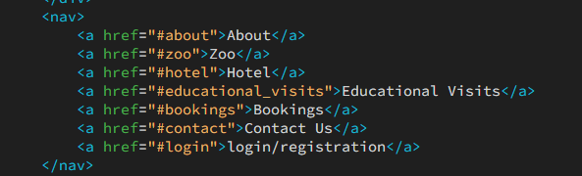

I can’t include the links for different pages yet as I haven’t created those pages once all these pages that I will create are fully functioning then in the “**href**” tagI will add the link for all the pages. Using CSS, I ensured that the navbar elements are evenly spaced. The colour scheme I chose for my navigation is green because this is colour of forest and it was align perfectly with the theme of the website. To make the text readable for all type of users I chose white colour to be the text colour, which will make links more prominent. Moreover, the logo that I have designed is sized appropriatley and positioned to maintain visual balance within the navbar. Navigation links are styled to provide clear visual to user, with hover effect that I have added for interactivity.

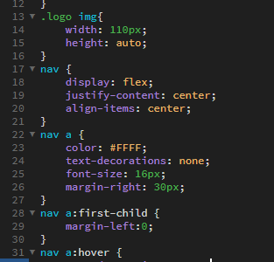

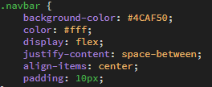

After the navigation bar, I created an image with text overlay section using both CSS and HTML languages. In my final solution I am thinking to add swipe images but for this prototype I only manage to implement one image, I positioned the text overlay over the image, ensuring it was cent rent both horizontally and vertically.

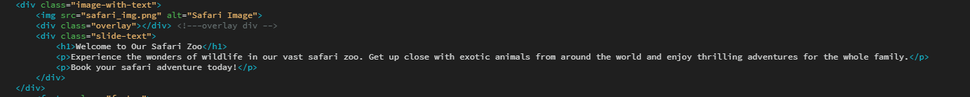

This is the snippet of HTML code where I have implemented the text overlay over the image. I make sure that the text is styled for readability, with appropriate font sizes and spacing using CSS.

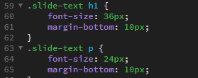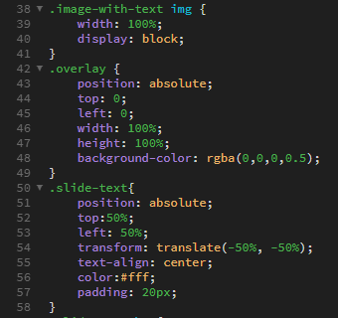

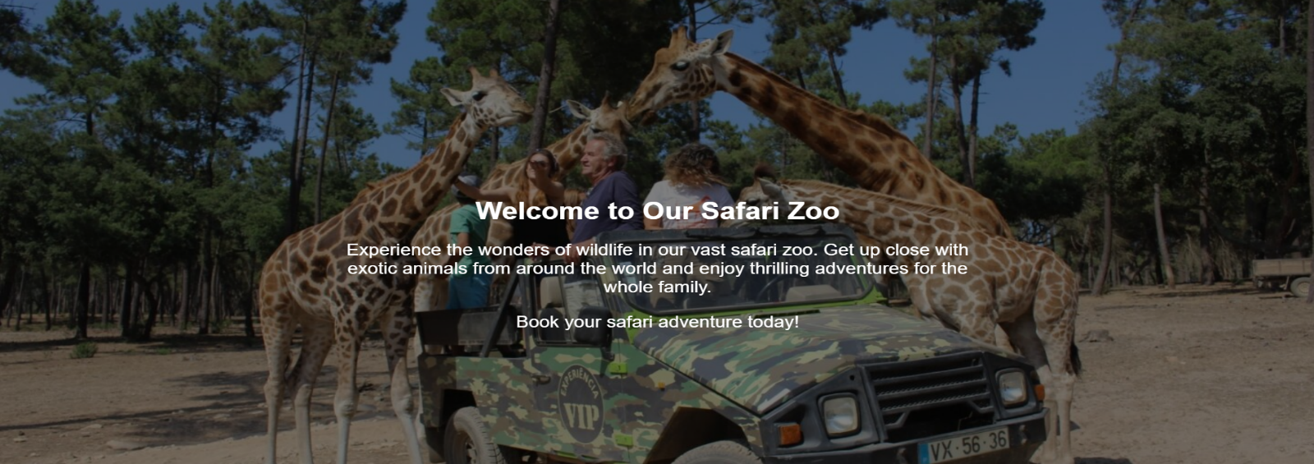

The last thing that I have created for my prototype is the footer, however I haven’t implemented all the links yet, but I will in my other versions of the website. Here is the snippets of the HTML code for the footer. 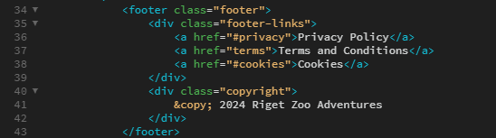

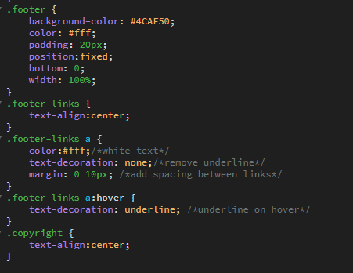As you can see there is just 3 links (privacy policy, terms and conditions, cookies). Using CSS I styled the footer to match the overall theme of the website, ensuring consistency in design. Links are centred horizontally aligned within the footer for easy navigation, with hover effects for the user engagement.

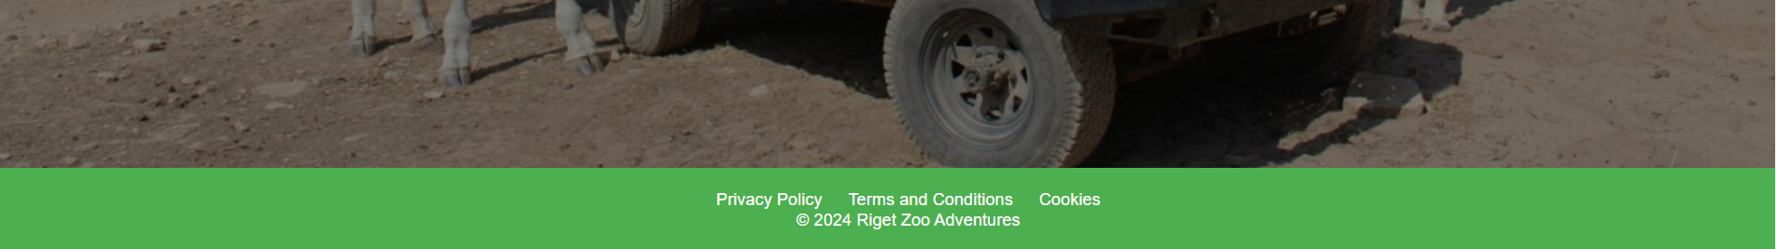

Overall, this is my first prototype which is quite simple, and many elements are missing, but I will make sure to implement those elements in my 2nd and 3rd  version of prototype.

**2ND version of Prototype:**

Today I have developed my 2nd version of the prototype. To begin with as I already have the navigation bar in my first prototype, So I just make some changes to provide the client and users better experience during the navigation to other webpages. When I added all the links for all the webpages that my client have suggested me to create, because of the number of links I needed to add in my navbar, the navbar was looking so congested. To fix this issue I created a top and bottom navbar just like this

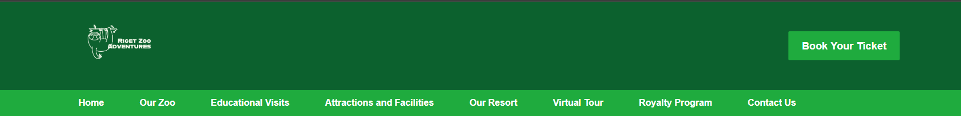**Top Navigation Bar**

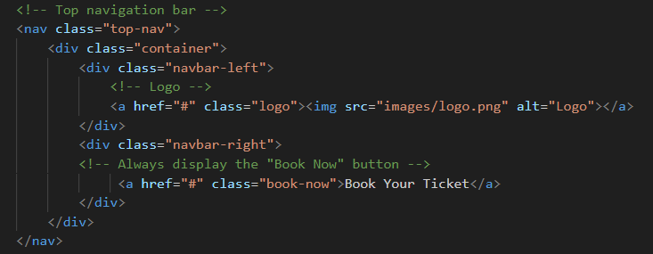The top navigation bar only contains the logo and “book your ticket” button. Here is the snippet of html code that I used to create the top navigation bar.

Here is the CSS I have used to design the top navigation bar.

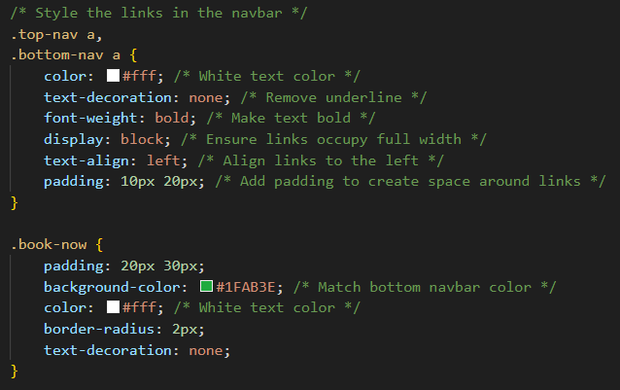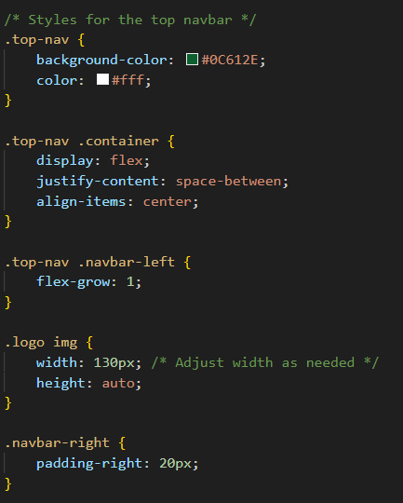

The top navigation bar serves as the primary navigation for the website. It contains logo of the website “Riget zoo adventures” on the left side and a prominent action button “book you ticket” on the right side of the navbar. I chose the dark green background colour for my top navbar which gives distinctive and visually appealing appearance. To ensure readability I chose white text colour which provides good contrast against the dark background.

**Bottom Navigation bar**

This is the snippet of my html code that I used for bottom navigation bar.

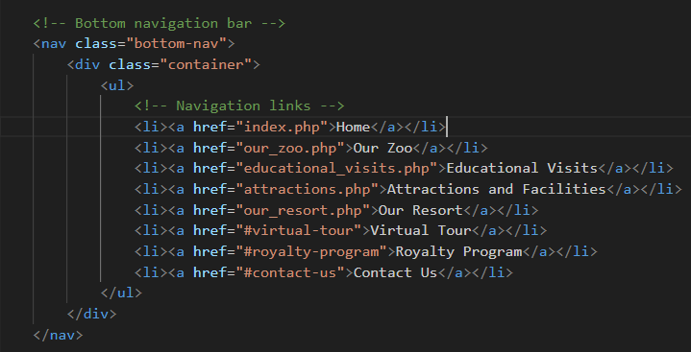

Mainly, this bottom navigation bar is for all the links of the webpages I will have in my website, I still need to add login and registration link in the navbar but for now I will focus on creating all the other webpages that I have in this navbar. The background colour I chose for bottom navigation bar is lighter shade of green which contrasts nicely with dark green used in the top navigation bar. This colour consistency creates a cohesive visual theme throughout the website. To also ensure readability I chose white text colour which provides good contrast against the background colour.

**Here is the snippets of CSS code that I have used for this navbar**

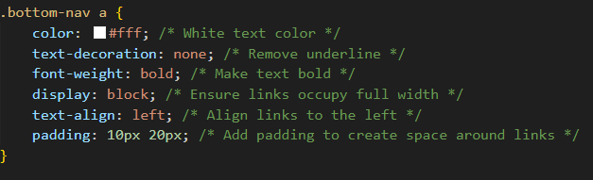

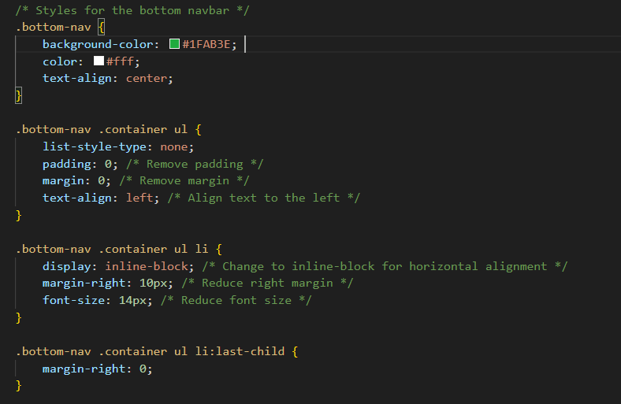

To make it easier and productive I have created a includes folder which will have my footer file, navigation bar file and header file, so then I don’t have to rewrite the code in every single webpage with the help of PHP I will include them in my webpage.

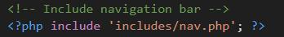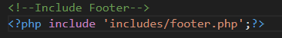

This is the code that I have included in my header.php file which are all the links to bootstrap CSS, font awesome CSS, and the link to main CSS.

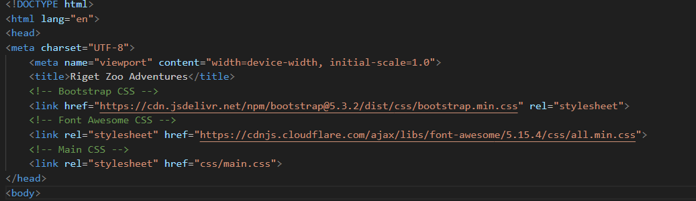

These codes are the one that I need in my every single webpage. So, to save time I have created separate files for the repeated code that needs to be included in all the webpages.

**Header**

Moreover, after the navigation bar I have implemented a welcome message for the users in the header section to make users feel welcomed when they visit this website. This section typically contains introductory content at the top of webpage. I added the container fluid div to maintain full width responsiveness. Inside I have added a jumbotron element, which is a like a showcase area with centre text alignment. Within the jumbotron there is a container div with title **<h1>and to add a paragraph I used <p> which have the welcoming message for users.**

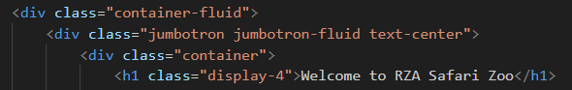



I chose the forest colour again in this section because it is giving the nice contrast with the navigation bar and looking good with my website theme. Again, for the readability I chose white colour which prominent the text.

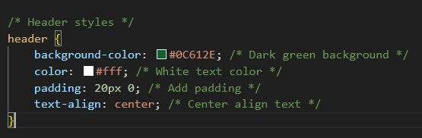

This is how it looks like with the text alignment in the centre with the welcoming message

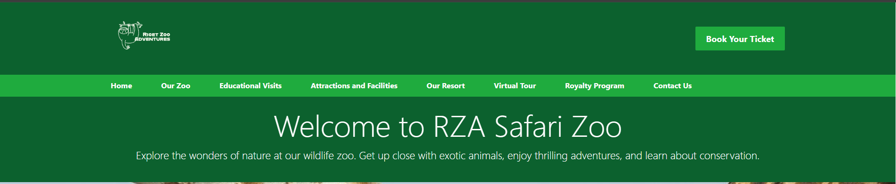



Furthermore, I have added the full-size image for home page which will give the user overview of the zoo and helps to attract visitors. This image also show the safari van they used for this zoo. Here is the snippets of CSS and HTML code which I used for this image to implement in the home page.

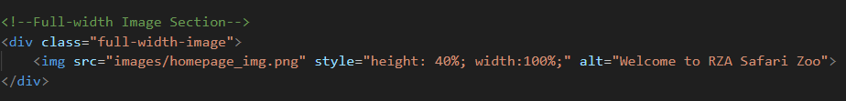

This section contains a single full width image of the home page. As you can see, I have added the CSS code with the html code to make it will show the accurate height and width of the image .

**Discount banner**

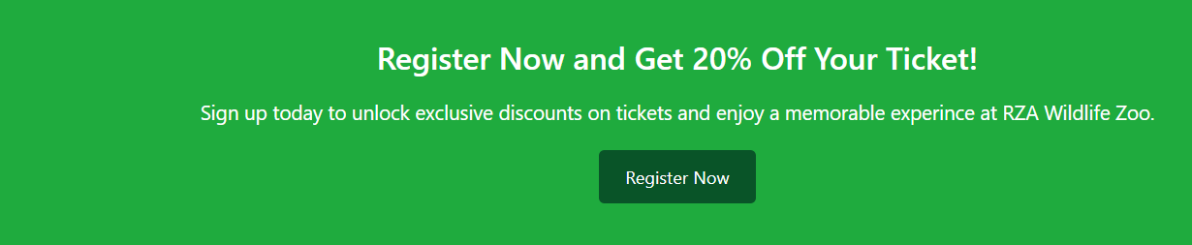

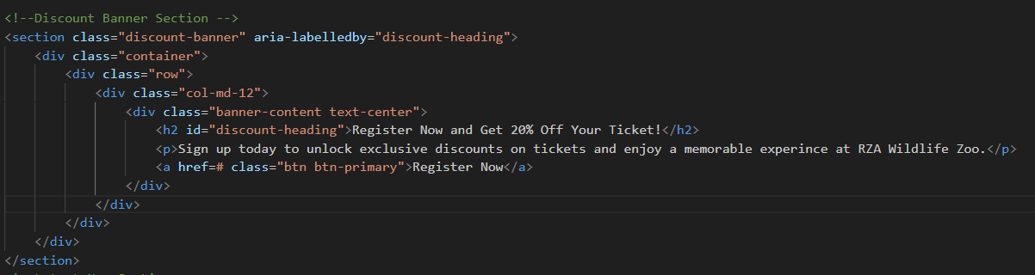Today I have added a discount banner which will encourage user to register their accounts to discover discounts on tickets. When I create a registration page then I will add that link in the href tag, so users can easily click that button and it will redirect them to registration page as when they see the discount they wish to go to registration page, so to make it easier for users and give them better experience I implemented this button.

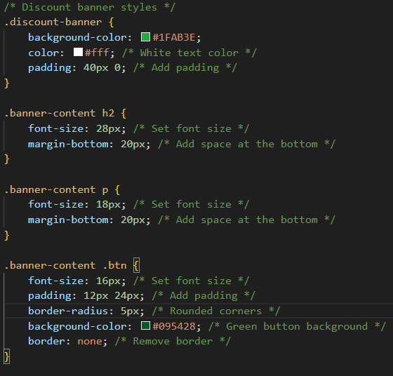I have added a container with a single row and column for content alignment, the content includes a heading, a brief description, and a call-to-action button linking to a registration page. I chose a light green colour for the banner which will prominent the white text colour and the registration button to dark green which will help all kind of user as it will be easy to see.

Also added a hover effect on the registration button to make it more visually feedback

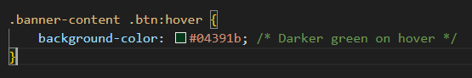

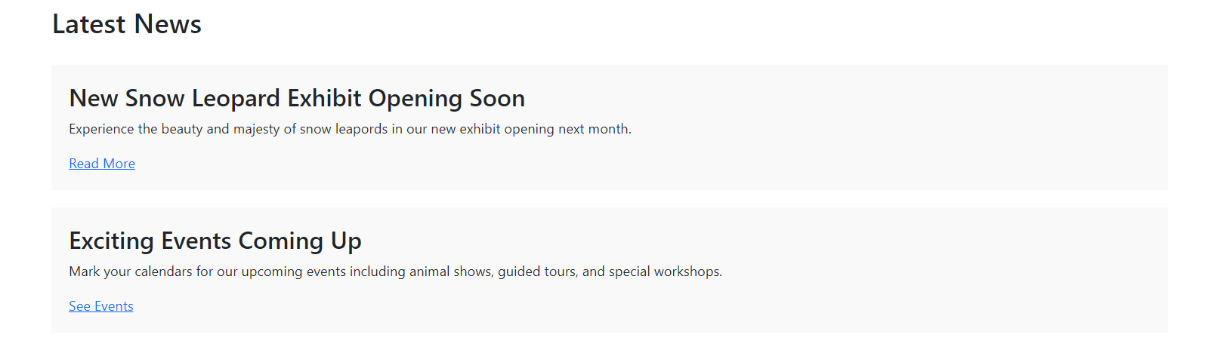**Latest news**

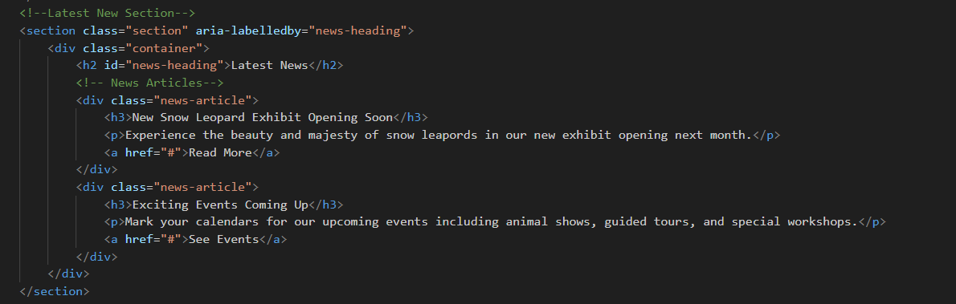This section presents the latest news or updates from the zoo. It includes a container with title and multiple news article and each news consists of a headline <h3>, a brief description<p>, and a read more link. I have taken this idea from Chester Zoo website as the website have a similar pattern for this. However, I still need to customise the text according to my website.

Background colour that I have chosen for this section is light grey which implies to induvial news articles to maintain the consistency with the service cards. To create separation from the edges I have added 20px padding around the content within the service card.

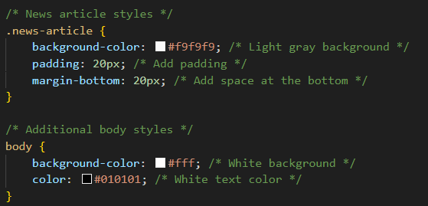

**Our Services Section**

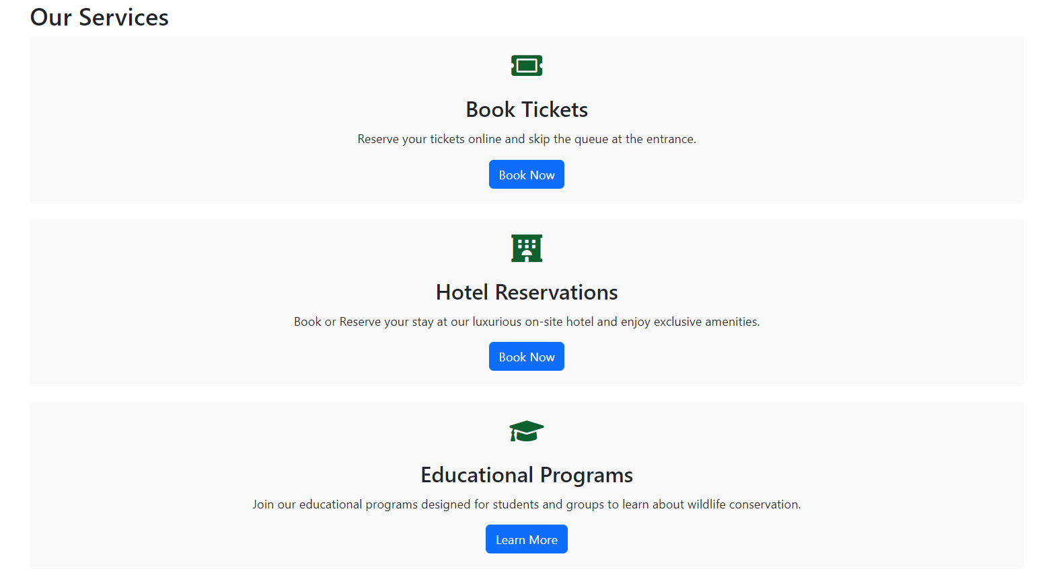

Today I have added our services section which showcase various services offered by the zoo. It contains a container with the title and multiple service cards and each service card includes an icon, title, description, and call to action button linking to relevant pages.

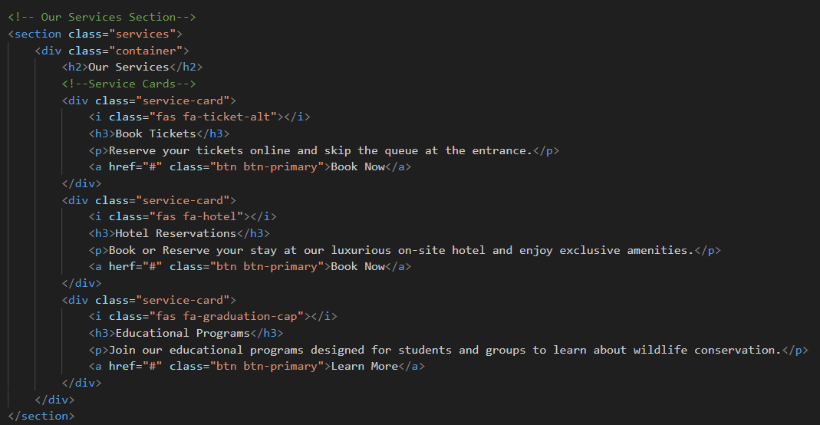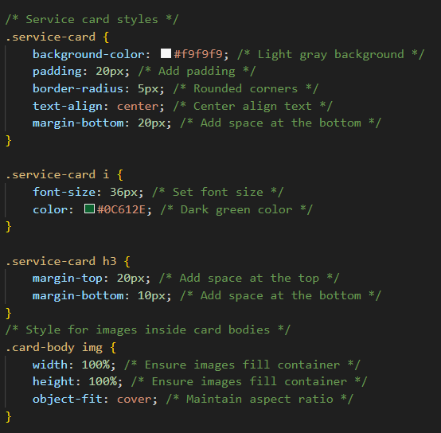

This section have the same background colour and the padding as news article.

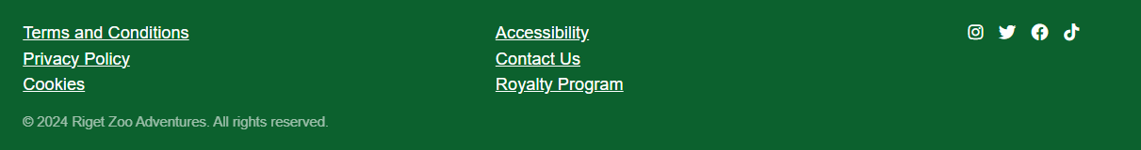**Footer section**

This footer contains the links for all the important pages and links for social media accounts

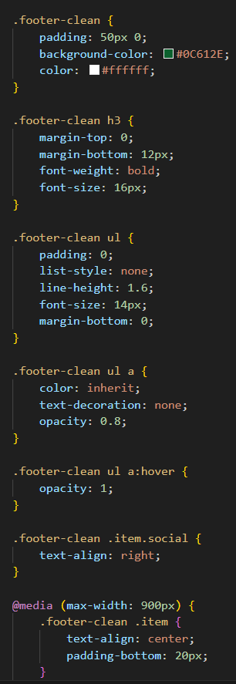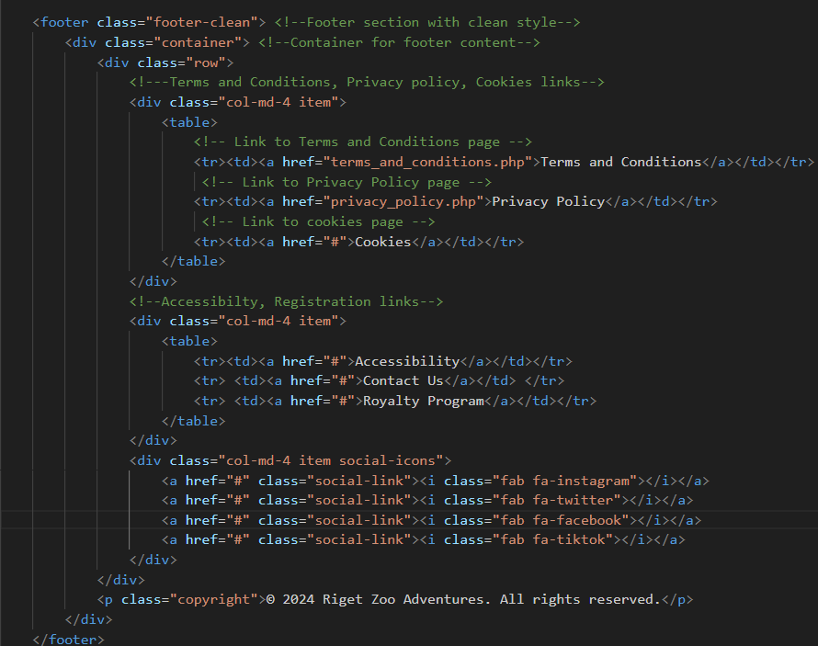

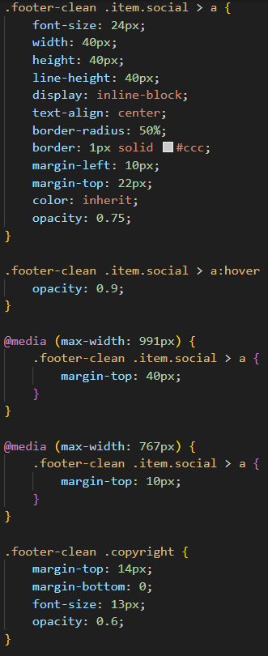

Background colour for the footer is dark green, which creates a visual contrast with the rest of the page. I have added 50px of padding above and below the footer content to improve spacing and visual balance. Added white text colour for better readability against the dark background.

**Our Zoo Page**

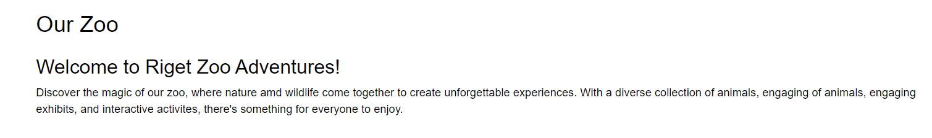

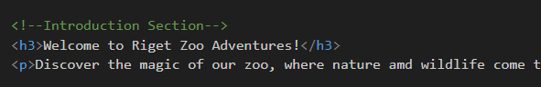This is the introduction section which talks about the zoo highlights.

After the introduction section in this page, I have implemented a card with an image and description which showcase the key highlights of the zoo.

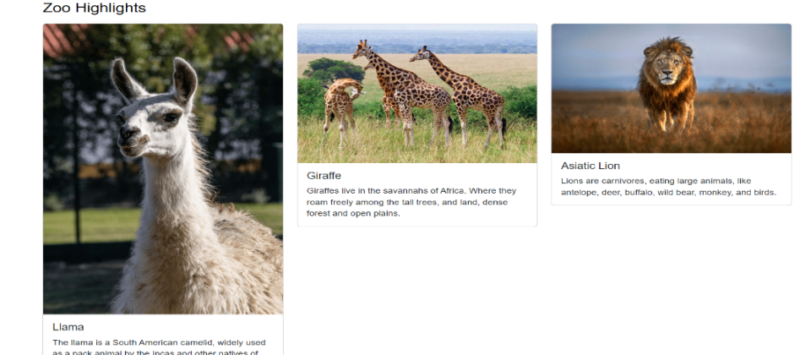

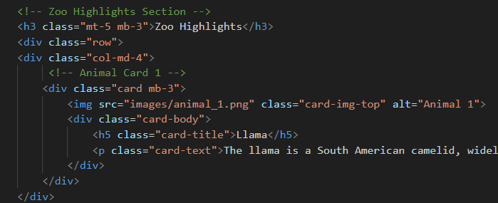

As this is not my final version of the website, so I haven’t completed this page I will add a zoom in and zoom out function in the map and also, I will add the prices of all the tickets but for now I have added a zoo section which contains the image of the zoo which I got it from google because this website is not going to publish so there is not going to be an issue on copyright law. Also, I don’t have the zoo map for RZA yet

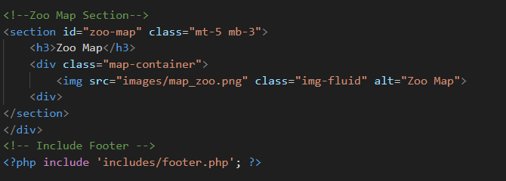

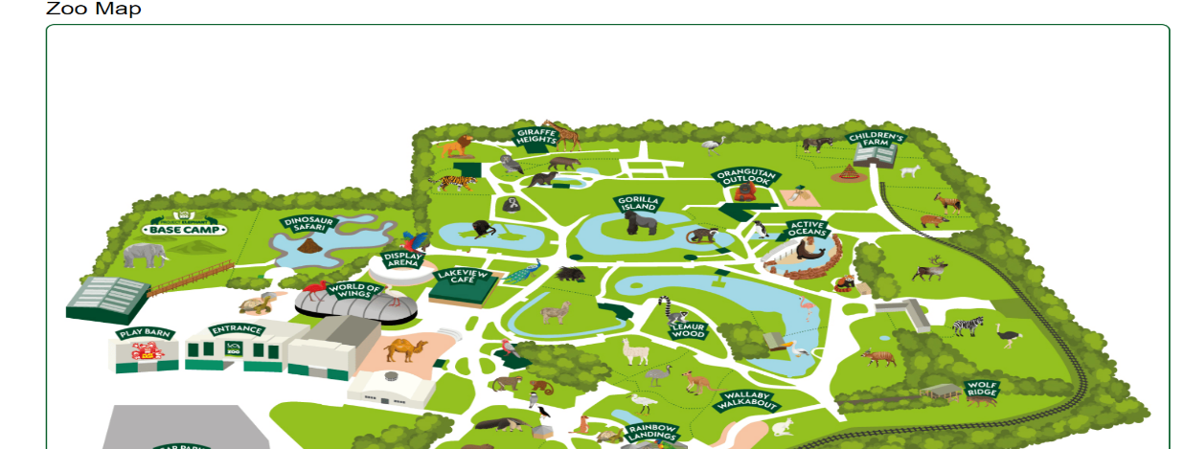

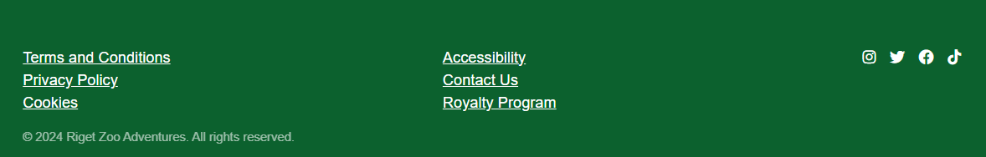After this I included footer using php

**Educational Visits Page**

In this page, I have included some YouTube videos for educational purpose. So, users who are interested in animal behaviour will learn something and will also interact the user to visit them and see them in person.

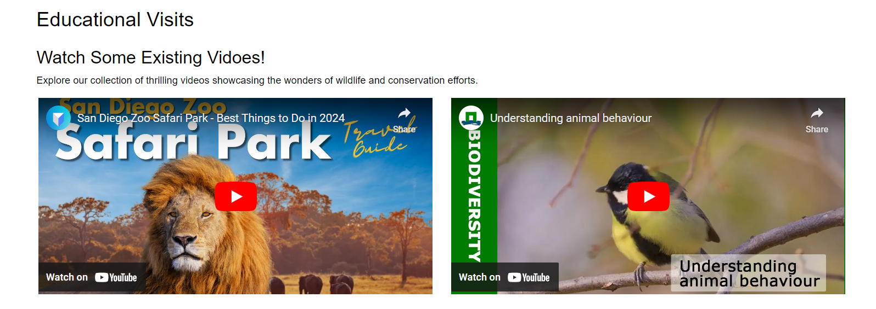

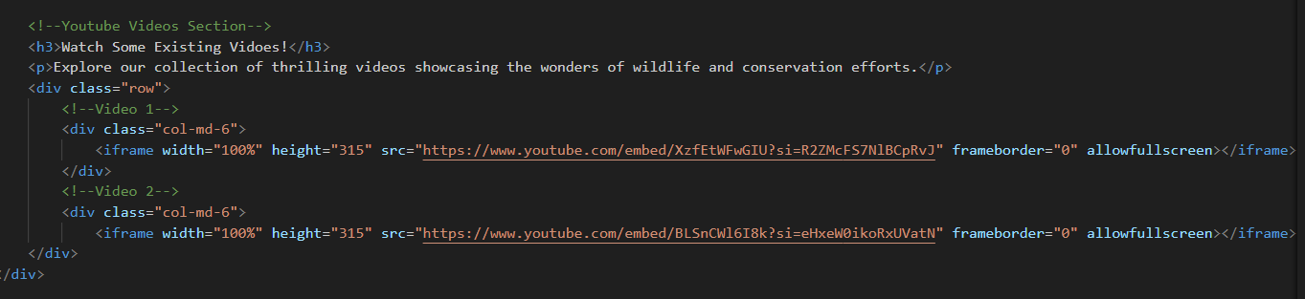

This is the snippet of my html code which I have used to implement these videos. I added the width and height with the code to make sure that it will display properly.

One of my client requirements is to have educational materials to support the education visits. So, I have included that in my education visits page

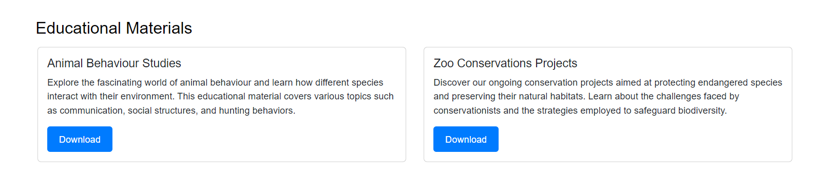

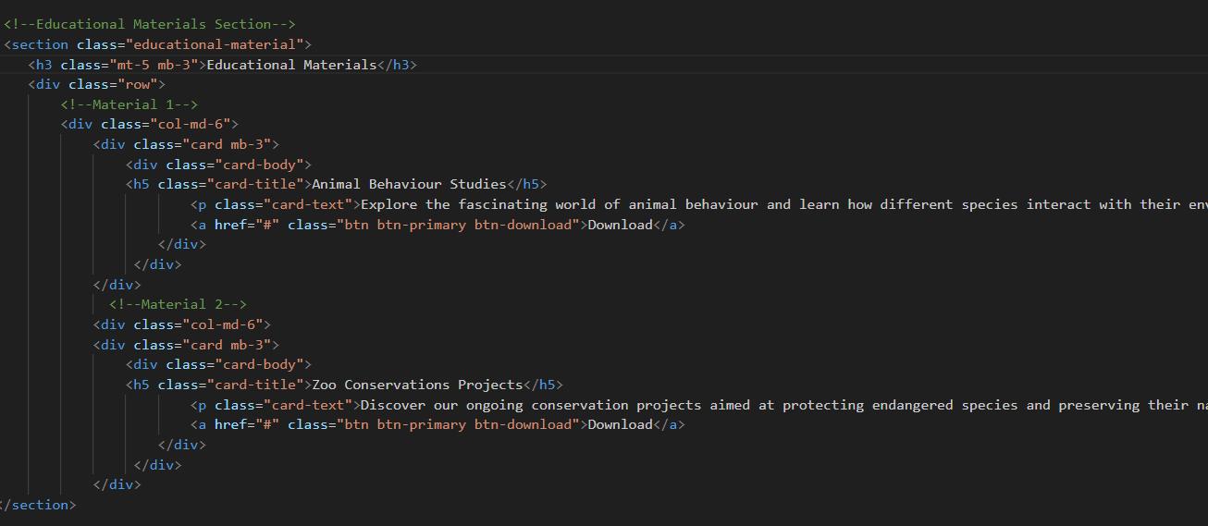

This is the snippet of my html code; I still have to add the links for educational material which I will do in my final solution. I also added the download option for these materials so users can download materials and learn in their own time also take the materials when they visit the safari zoo.

Also, in my final solution I will add all the other resources I have listed to give user better experience when they visit this page and help them to gain information.

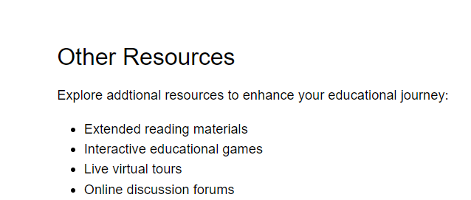

**Our Resort Page**

When user visit this page, the first thing they will see is the resort overview which I have included to display all the facilities we offer.

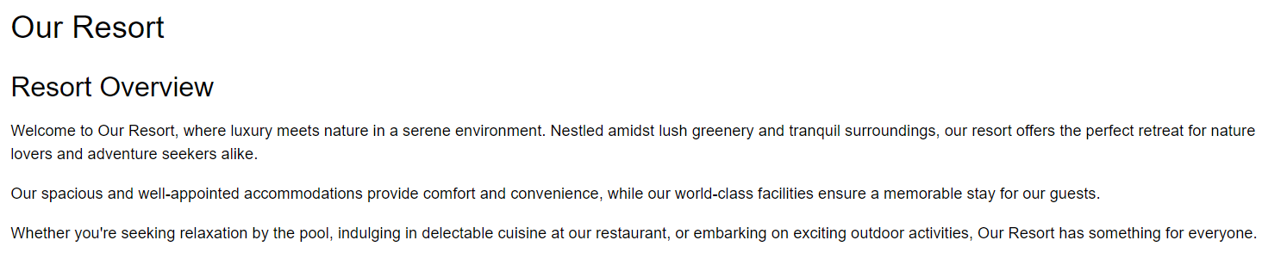

Then I have added the card again with title, image, book now button and information about the accommodation to help user choose their desire accommodation.

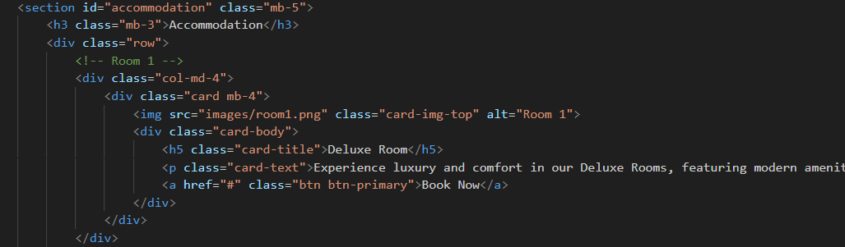

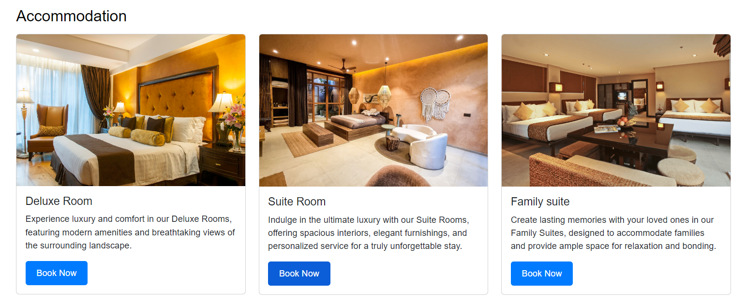

These “**book now**” button will redirect user to resort booking page.

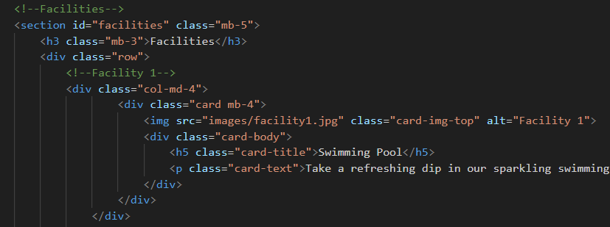

This section highlights the facilities offered by the resort. I have used the same structure to the accommodation section, its starts with heading and inside the section, there is a div with the class row, indicating that it contains cards which represents various facilities available at the resort.

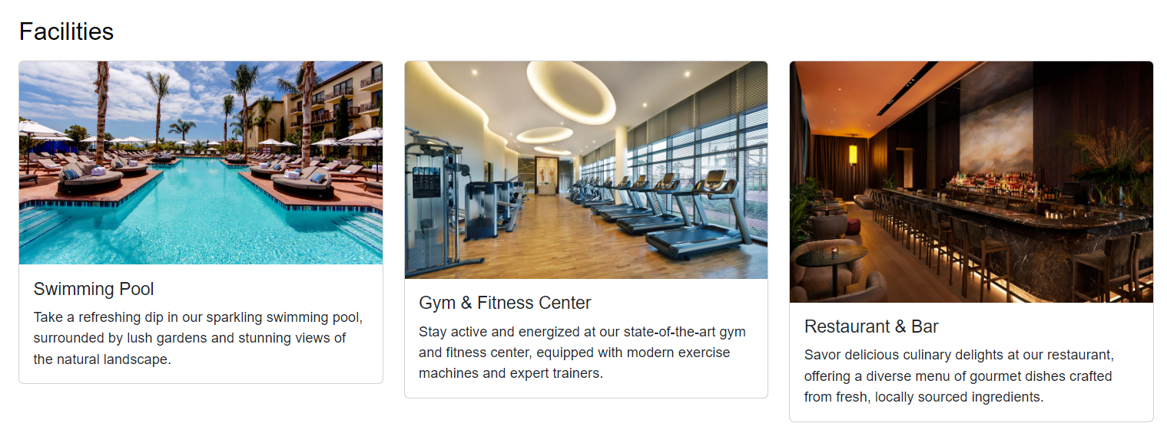

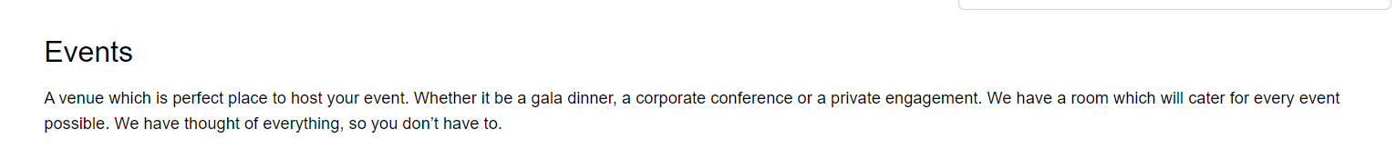

I have also included the contact us information in this webpage, but also in my final website I will have contact us page.

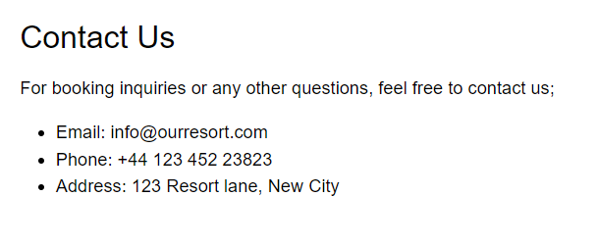

**Attractions Page**

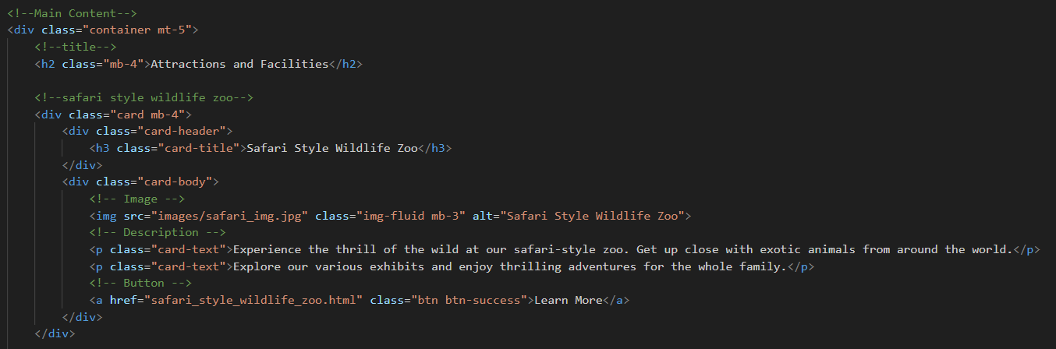I have kept this page very simple for the users and display all the attractions and facilities that Rigit Zoo Adventures offers.

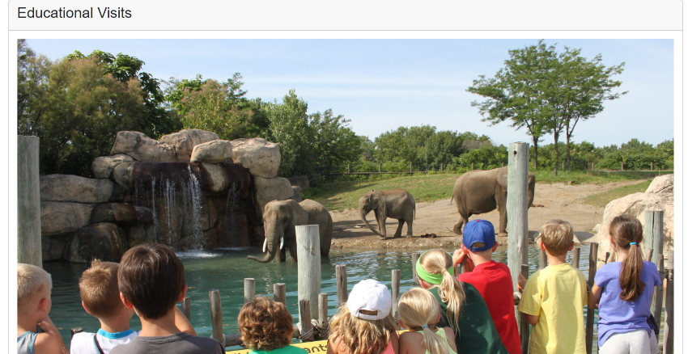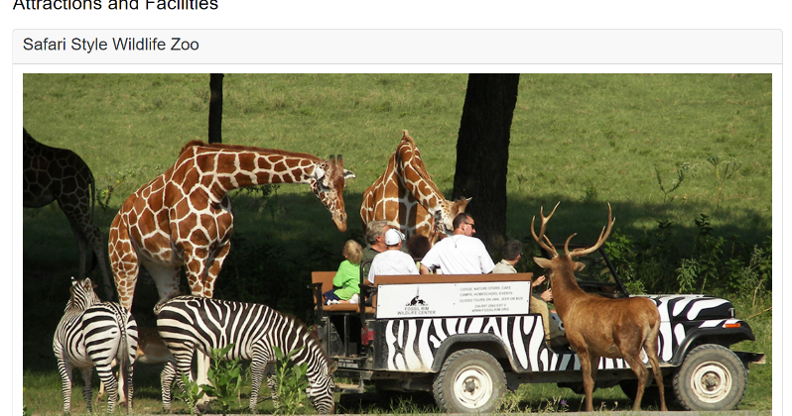

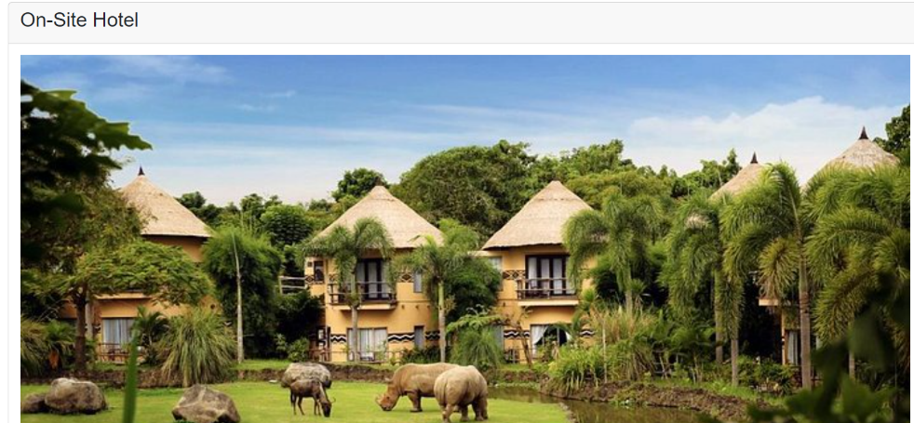

They also contain a little information about the attraction and learn more button like this.

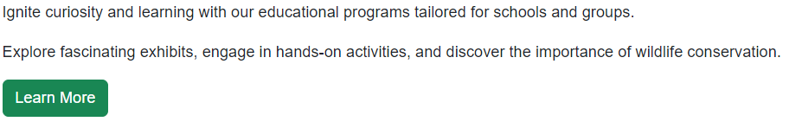

**3rd Version**

This is my last version of this prototype. I will implement some more features and pages to meet my client requirements and make changes in of the pages that I have created in my 2nd version. However, I will not change anything major from my 2nd version as I am very satisfied with everything that I have created so far.

**Sign up page:**

I have created sign up and login page today and connected it with database. I tried to make them as user friendly as I can and for that I added some useful error messages. I implemented only one link for both forms, when user clicks the link, it will redirect them to user registration form which I add a link for login page for the registered users that link will redirect them to login page.

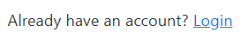

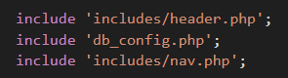

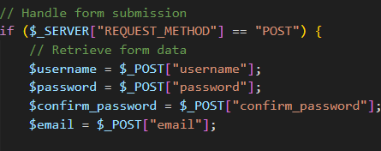To start off, using php I included all the necessary files such as navbar and header which contains all the bootstrap and CSS links, also I included db_config.php file to establish a database connection. I created a variable $registration_error to store any registration error messages.

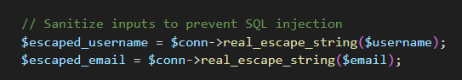It checks if the form is submitted using the request method variable. Inside the form submission handling, it retrieves form data like username, password, confirm password and email.

I implemented this code to sanitize inputs to prevent SQL injections using

$conn->real_escape_string().

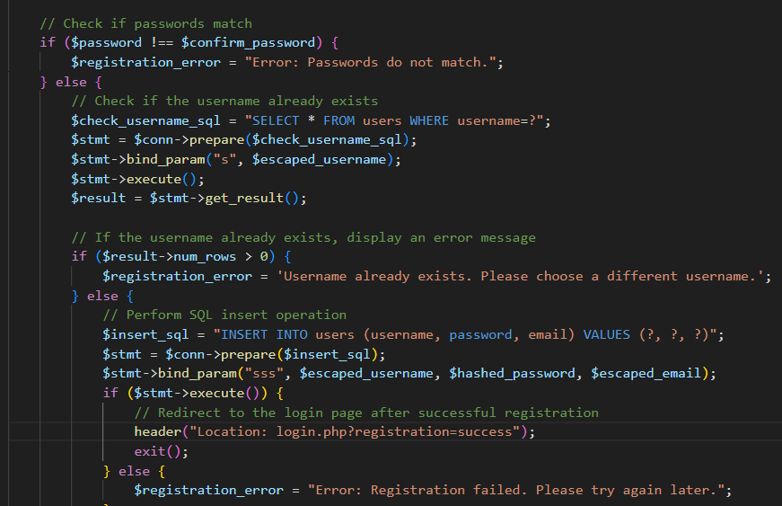

Mainly this part of code is for validation of user input as its check if users’ passwords match, if not then they will receive an error message, checks if the username already exists in the database, if it does then they will again receive an error message which has been set using the variable called $registration_error.

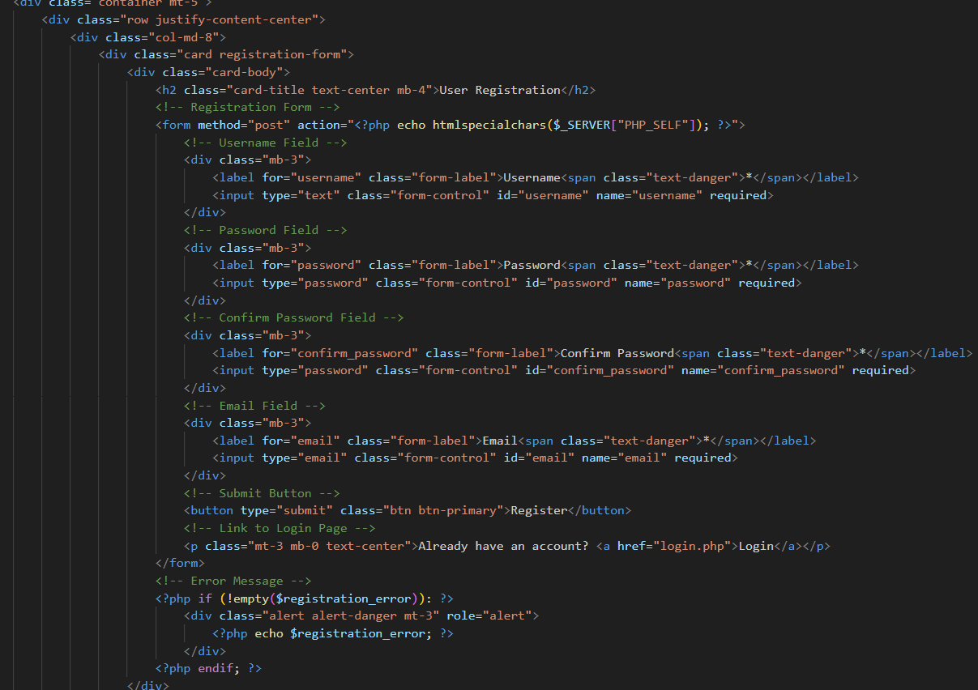

This section is the registration form I used HTML code for this form and bootstrap CSS and custom CSS to style this form. This form includes fields like username, password, confirm password and email. Also used PHP to echo the value of $_SERVER[“PHP_SELF”] in the form action attributes to ensure that the form submits to the current page. Lastly, this page contains navbar, footer and the form.

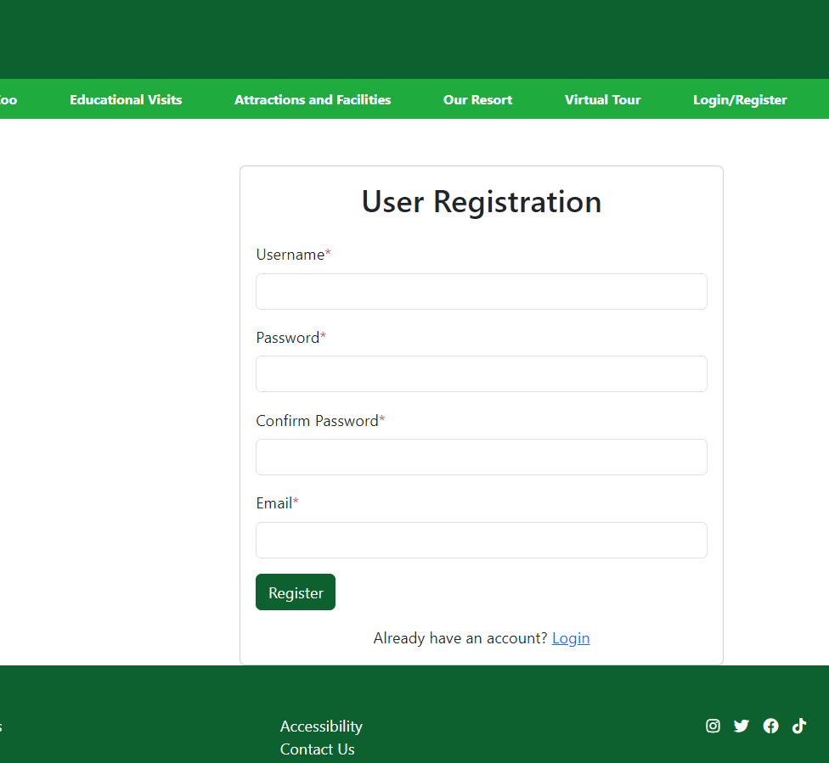

**Login page**

I used the same layout for this page as I included navbar, footer and the login form. This is the snippet of login page

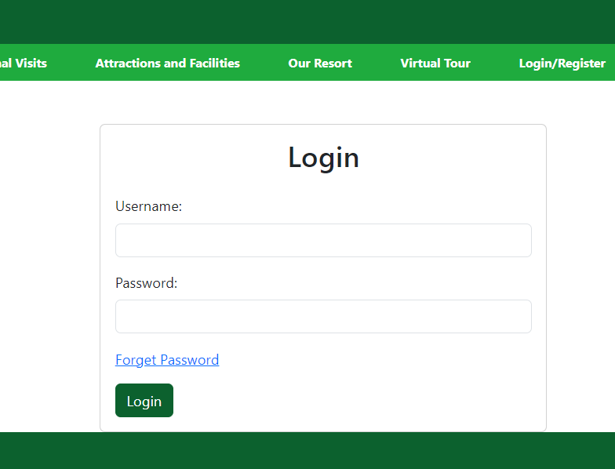

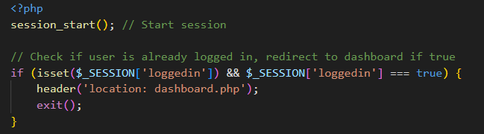

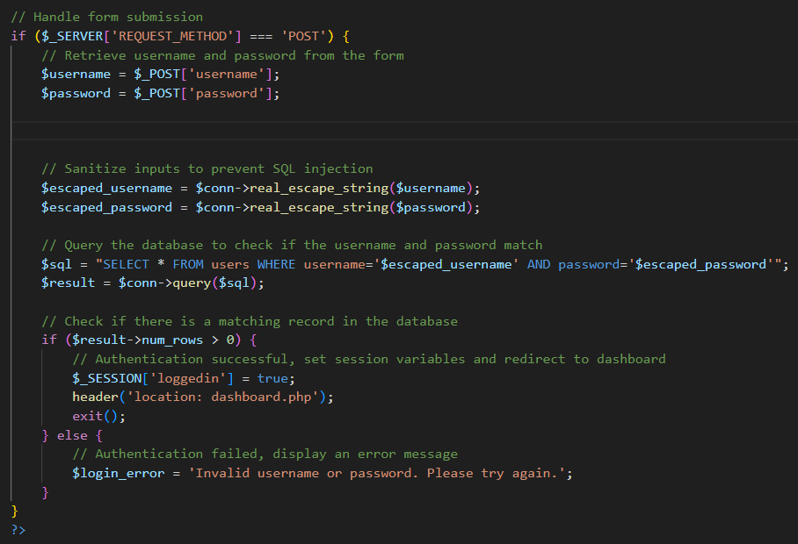I used session_start function which starts a new function or resumes the existing one. Sessions are used to persist data across multiple page requests. Furthermore, it checks if the user already logged in for that I used ‘loggedin’ session variable. So, if the user is logged in, it redirects them to the dashboard page and exits the script using ‘exit’(). I have also included all the same necessary files that I have used in registration page.

This block of code that I have implemented checks if the form has been submitted via the POST method. If it has, it processes the form data to authenticate the user. It also retrieves the username and password from the form, sanitizes them to prevent SQL injection, also checks the errors and handles them appropriately.

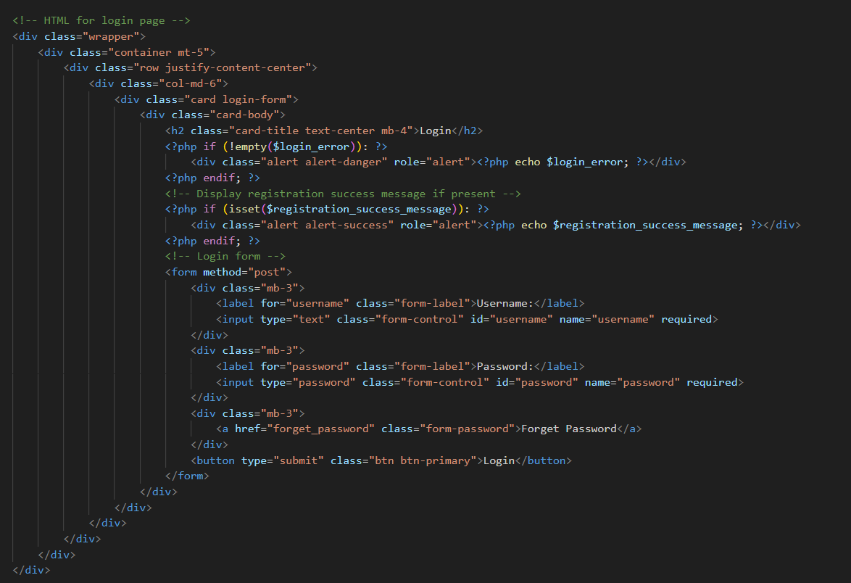This is the snippet of html and php code that I have used for my login page

This is the snippet of my db_config.php file and db_creation.sql file

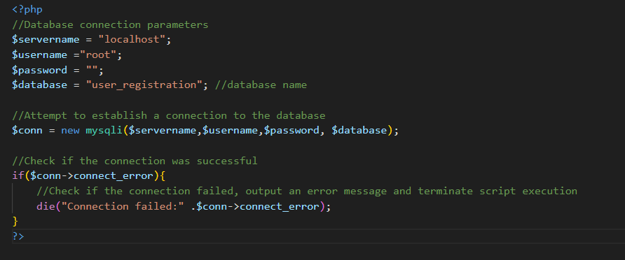

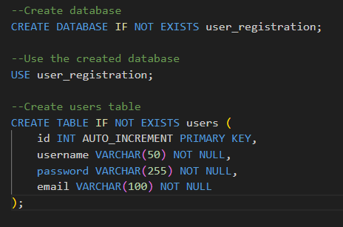

Also, I created a logout function which will log user out and redirect them to home page

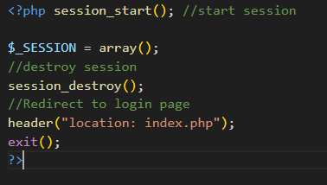

In creating the website for RZA Riget Zoo Adventures, I have implemented several guidelines to ensure that the user have user-friendly and informative experience. The terms & conditions page serve as a guidebook for users, outlining the rules and regulations for website usage. This page covers aspect like intellectual property rights, content licensing and liability disclaimer. By adhering to these guidelines, my website ensures clarity, fairness, and compliance with legal standard, ultimately fostering a positive user experience. The Cookie policy page outlines how cookies are utilized on the site, ensuring transparency regarding data collection and usage (GDPR). It explains the purpose of cookies, including analysing website traffic, clarifies the type of cookies used, such as session, persistent and third-party cookies, along with instructions on how to manage them. The Privacy Policy page contains the principle of data protection, detailing the information collected, its usage and disclosure practices. This page also emphasizes the importance of user privacy and provide contact information for inquires.

**Terms and Conditions page**

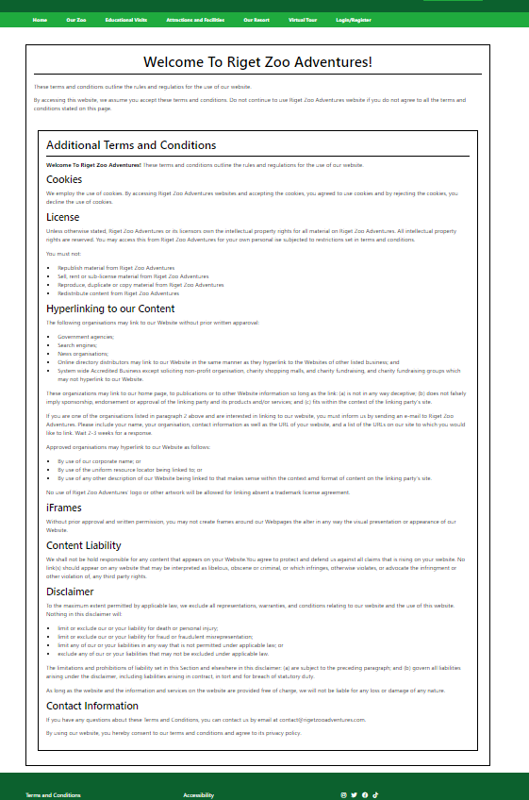I included all the important information about the terms and conditions in this webpage.

**Cookies Page**

This is my cookie page which contains all the information that users will need to decide if they like to accept or decline the cookies when they visit RZA website.

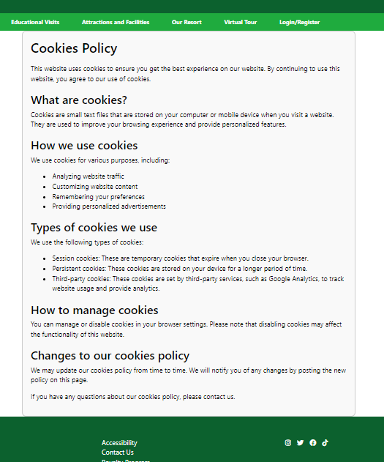

**Privacy Policy page**

This is my privacy policy page. I have kept it very simple for the users and included all the important information they should know about RZA privacy policy.

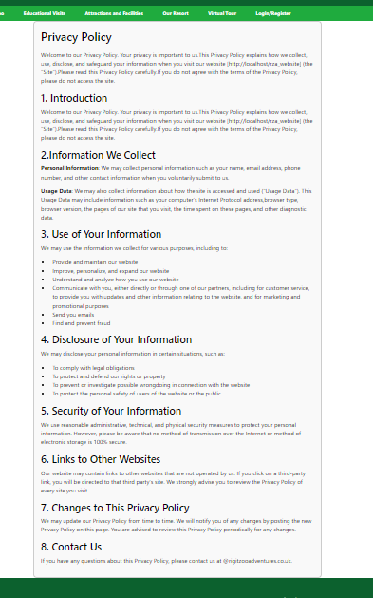

**Our Resort page**

I kept this page same as it was in my 2nd version, however I have included the pricing section for all the pricing of the rooms that Riget Zoo Adventure offers

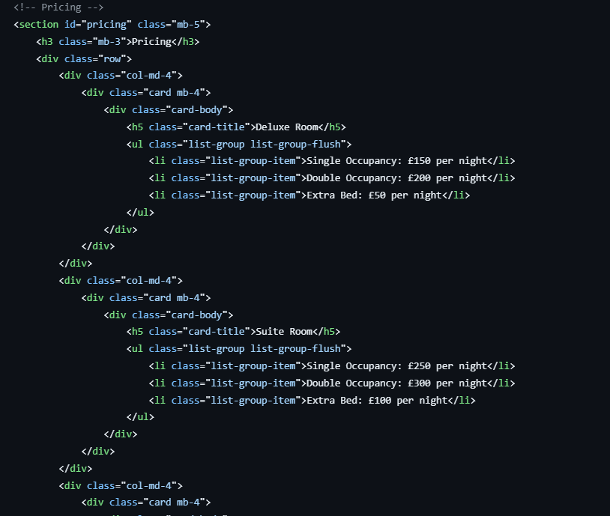

This is how it looks like in the webpage

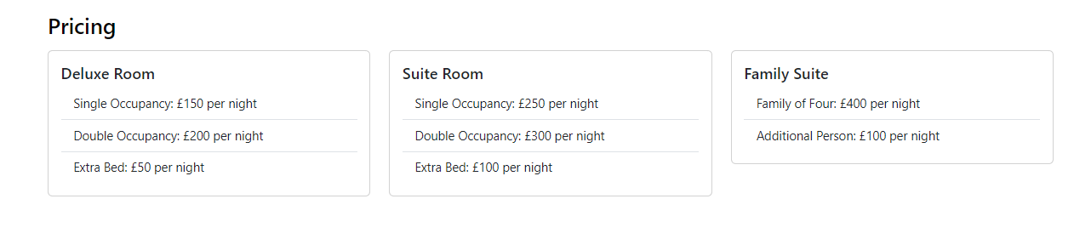

I also added the pricing for zoo tickets in our zoo page

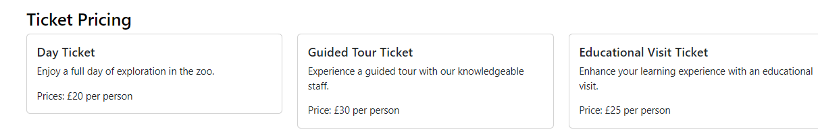

**Zoo tickets booking page:**

Today I created ticket booking page for zoo tickets. This is the snippet of this page:

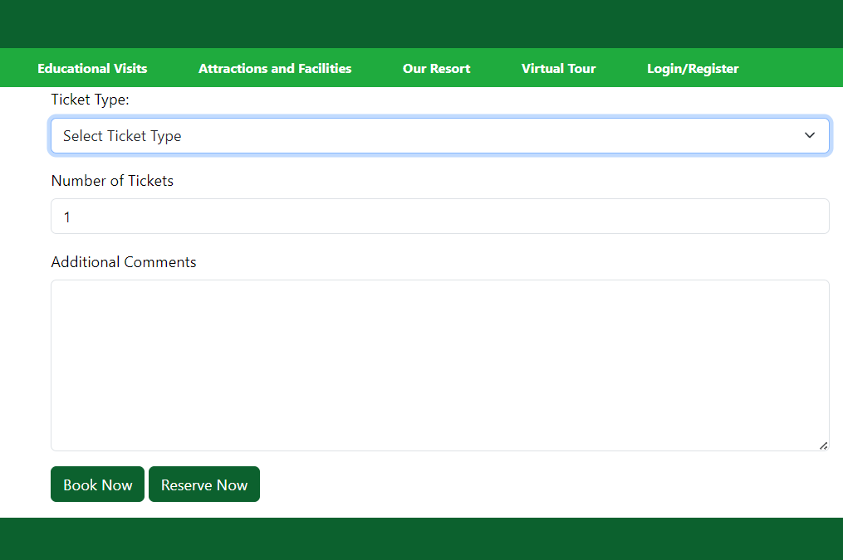

To start off, I used JavaScript for toggling additional fields based on user input.

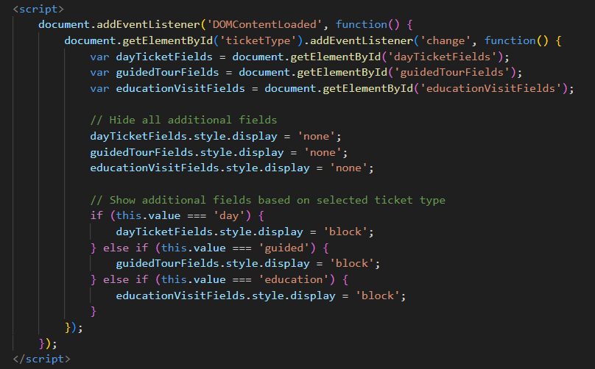

This script ensures that only the additional fields relevant to the selected ticket type are displayed, while hiding the others. This can provide a better user experience by presenting only the necessary from, fields based on users’ selection.

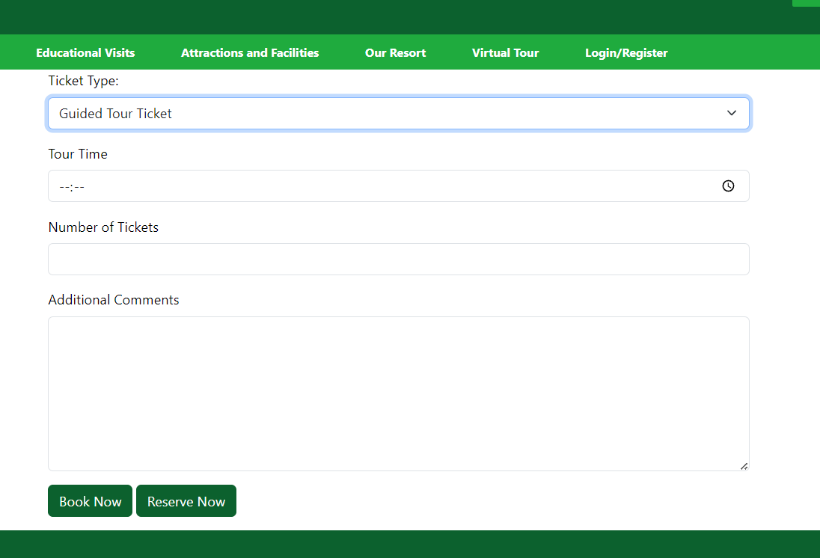

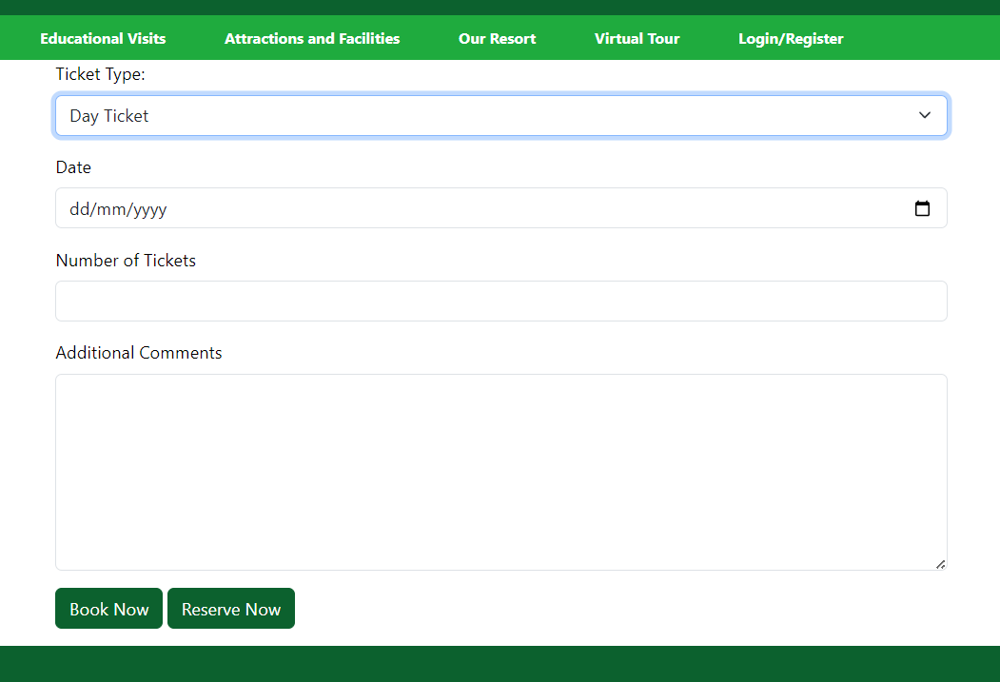

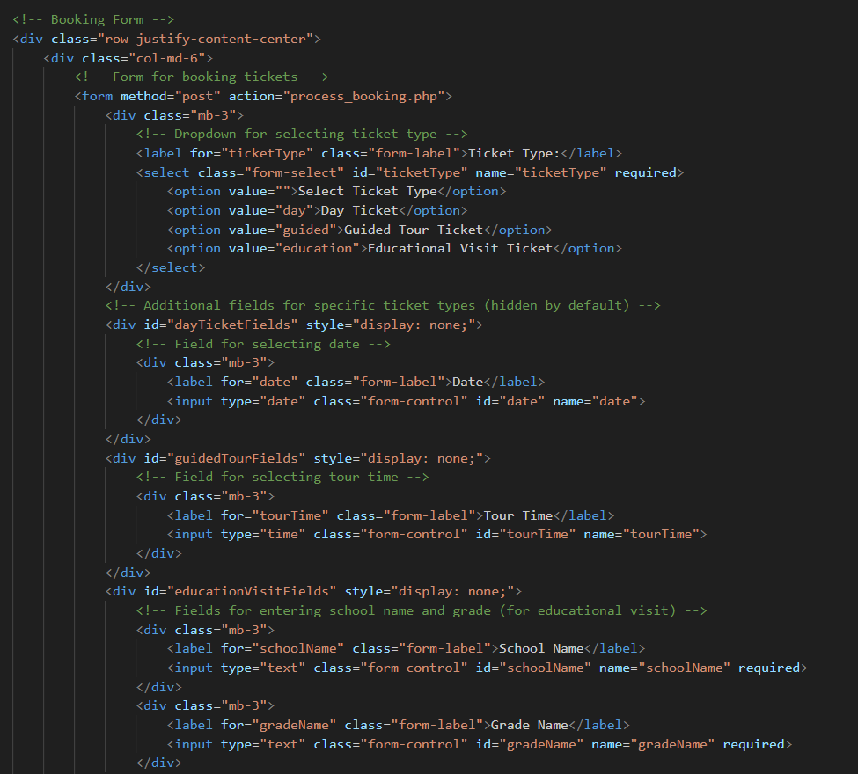

This is the html booking from which contains all the booking fields. I also added two buttons so user can either book a ticket or they can reserve their tickets.

**Resort booking page:**

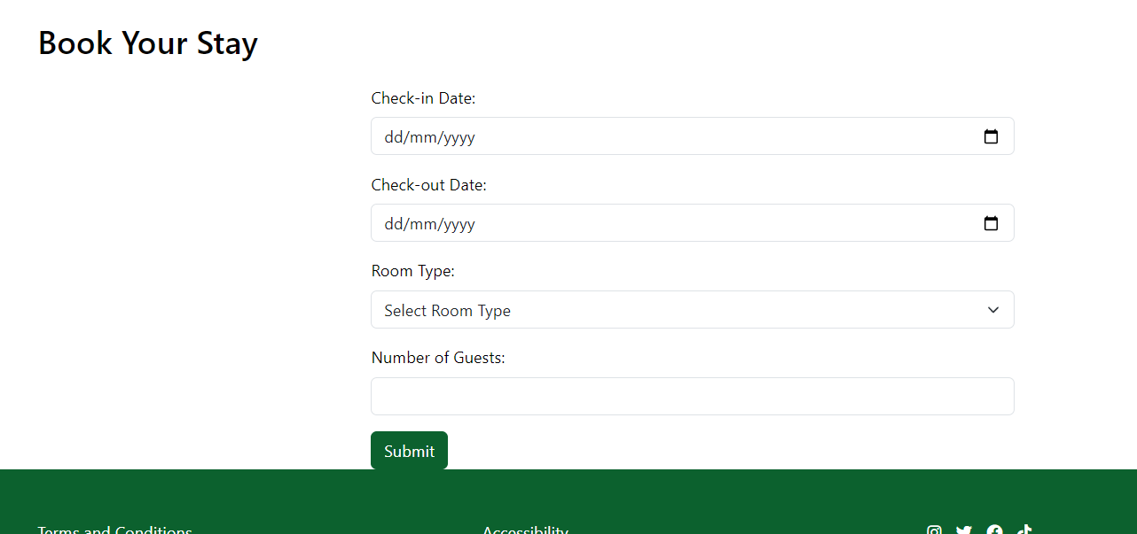This is my resort booking page

Users can book their rooms using this page. This form have all the required fields.

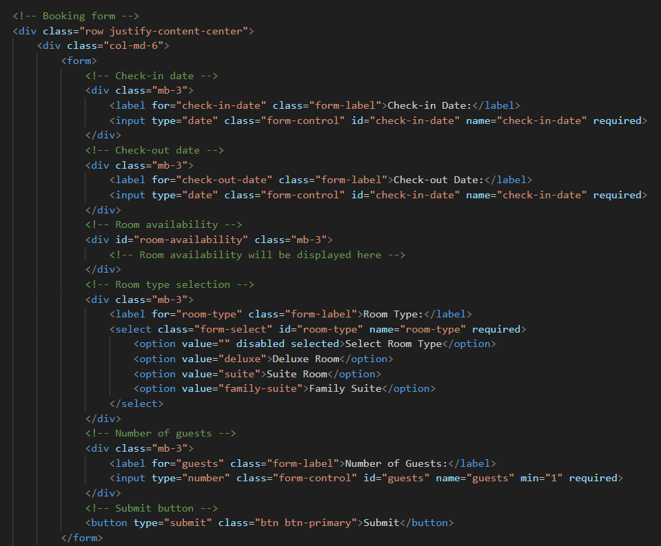

As you can see, I don’t have email and phone number field which is most important which I realised after the connection with database, but I will make sure I will add those two fields in my final solution.

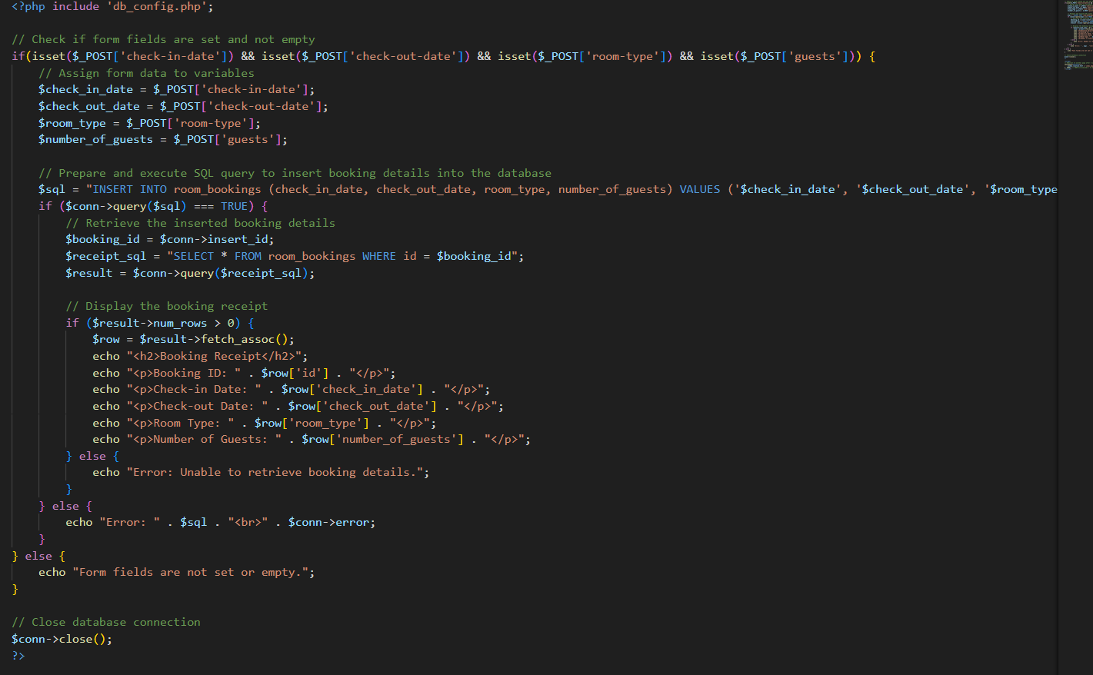This is my process_room_booking page which I used to connect with database.

I also have added JavaScript which will redirect user to the home page after it display receipt for 5 seconds.

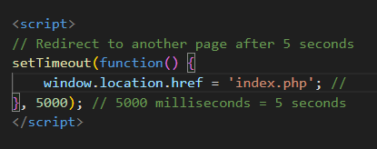

**Cookies Consent banner:**

I added this my banner in my final solution as I think was the important part of the website that was missing. Which I have implemented in my final version of the website.





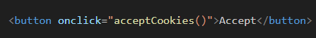This div displays a banner regarding the use of cookies on the website. I added a very simple message about cookie usage and two buttons one is for accepting the cookiesand the other one is for declining.

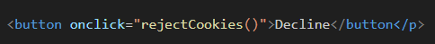

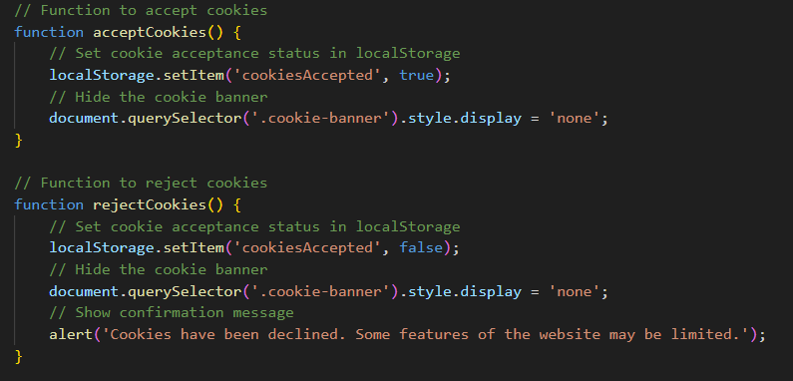I also implemented JavaScript to handle user choices regarding cookies

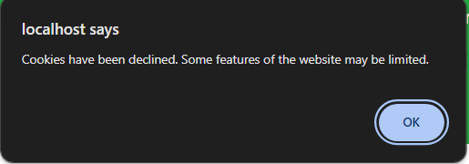This script contains the functions acceptCookies() and rejectCookies(). These functions that I have used handle the user’s interaction with the cookies consent banner, strong their preferences and updating the display accordingly. If users reject the cookies, they will receive a confirmation message like this.

And if the user accepts the cookies, then this banner will disappear to make better user experience .

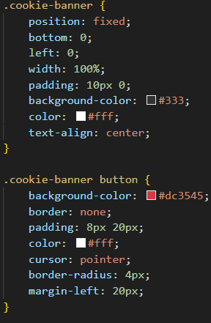This is a fixed banner at the bottom of the viewport, and I have chosen different colour from my website because this information is very important so it should be visible for any user which is why I also added define red buttons.

As I have mentioned earlier that I will add name and email field in room booking page as I think these two fields are very important because in my website users can book their rooms and ticket without have to login or register their accounts however for manage their bookings, they need to register so they will be able to cancel or find details about the bookings.

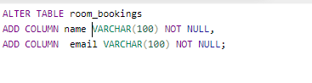So, I have added the important fields into the room bookings table so then they will receive an email about their booking

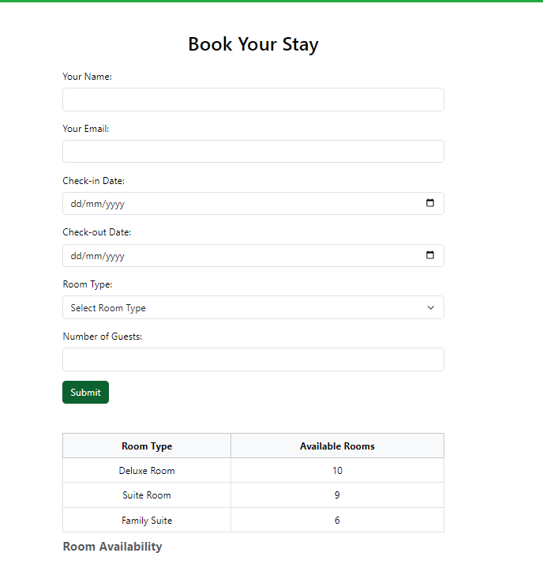

As you can see, I also added the availability table which will use the real time information to show the available table but as for now I just added this table in this version of my prototype but I will implement this feature in my final solution because it was one of my client requirements.

I also have added validation in this page which will validate all the fields in this from.

These are JavaScript snippets that I have used for validation

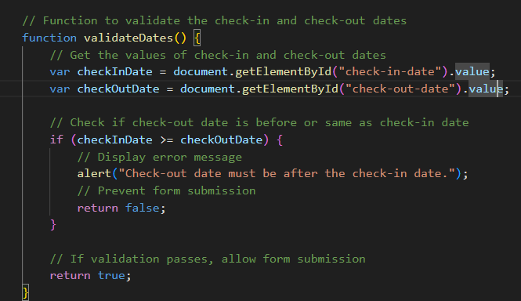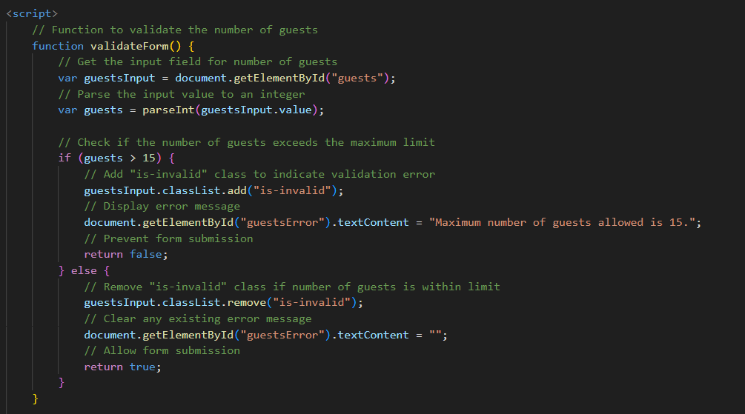

**Accessibility of the website:**

**Navigation bar:**

I used sematic HTML element such as <nav>,<ul> and <li> for better structure also I added descriptive alt text to the logo image using the alt attribute. I ensured that the navigation links are accessible via keyboard navigation and provided visible focus styles for better usability.

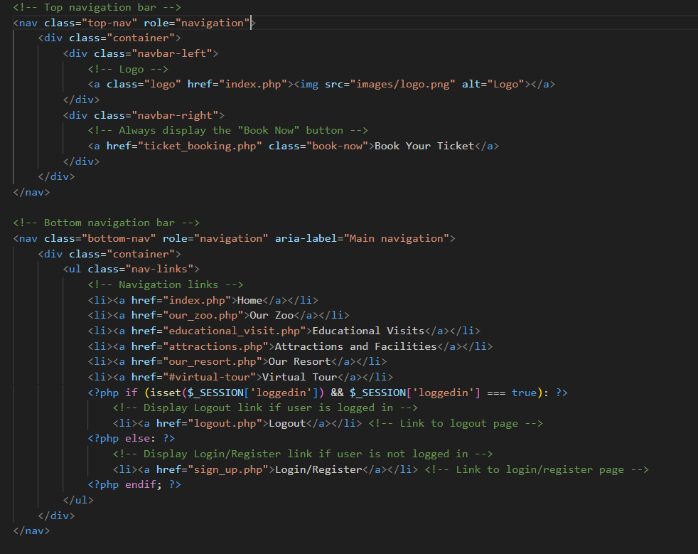

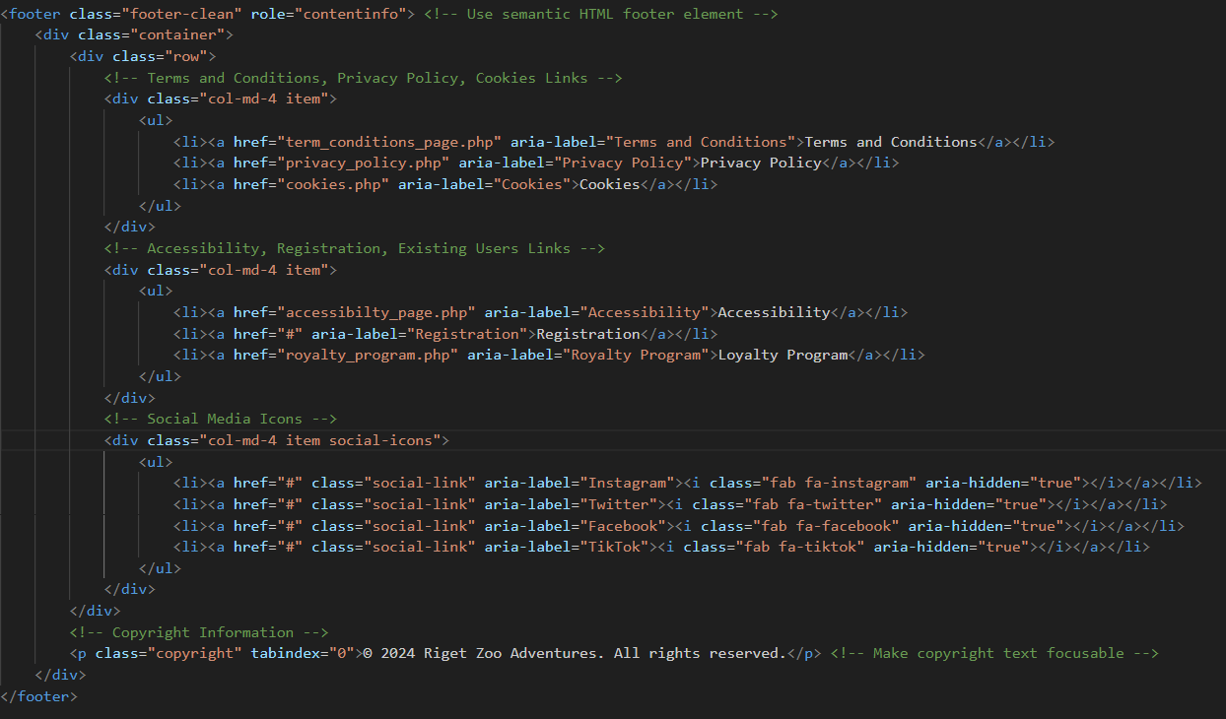**Footer**

I replaced the <table> elements such as <ul> and <li> elements for better sematic structure and also added role=”contentinfo” to the footer element to indicate its purpose. I added aria-label attributes to the links for better accessibility. I made the social media icons focusable by adding tableindex=”0” to the copyright text, allowing keyboard users to focus on it.

**Homepage**

I added tabindex=”0” to elements like buttons, links and cookie consent message to make them focusable via keyboard navigation. Users can now navigate through these elements using the “Tab” key, enhancing keyboard accessibility.

**Our Resort**

I added descriptive alt attributes to all the images for screen readers to describe the images to visually impaired users and also added tabindex=”0” to “Book Now” button to make them focusable for keyboard navigation, ensuring users can access them using the Tab key.

**Our Zoo**

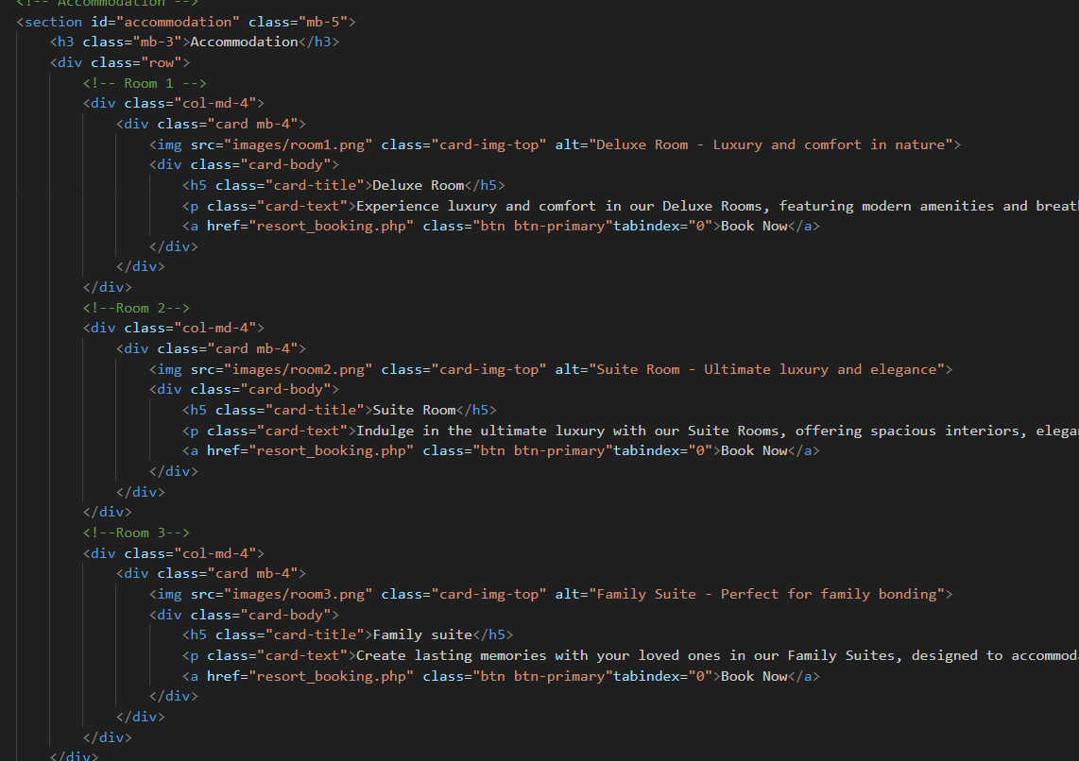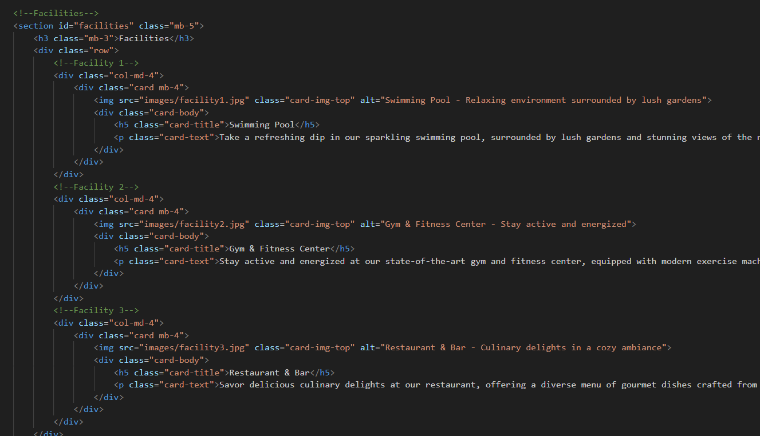

I added descriptive alt attributes to all the images for screen readers to describe the images to visually impaired users and also custom css styles have been added to enhance accessibility such as colour contrast, font size and focus indicators.

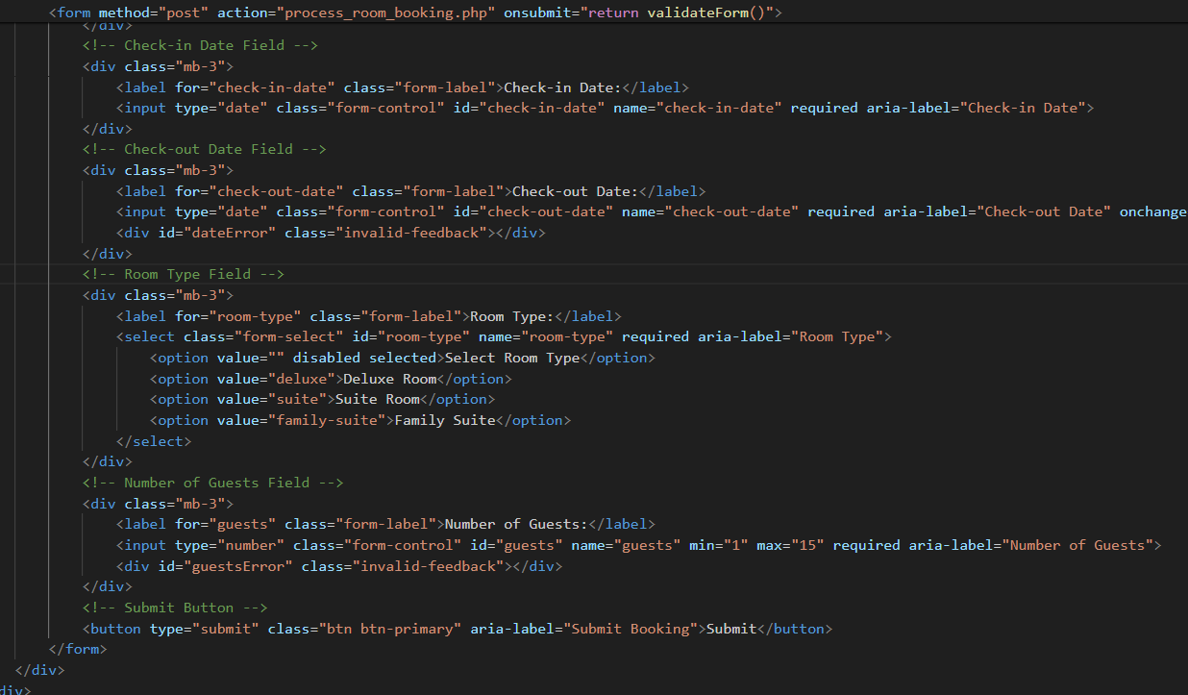**Booking resort page**

I have added labels elements for each form input field to provide clear labels for screen reader users also added aria-label attributes to buttons and interactive elements to provide additional context for screen reader users and to ensure the use sematic HTML elements to provide structure and meaning to the content.

**Booking ticket page**

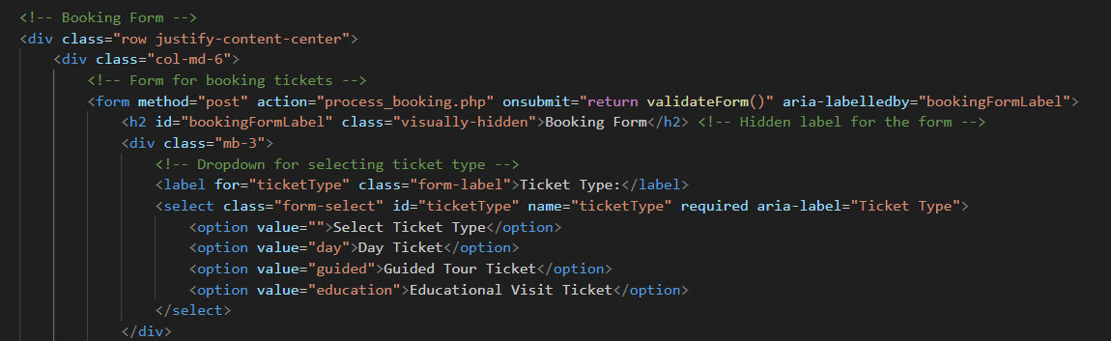

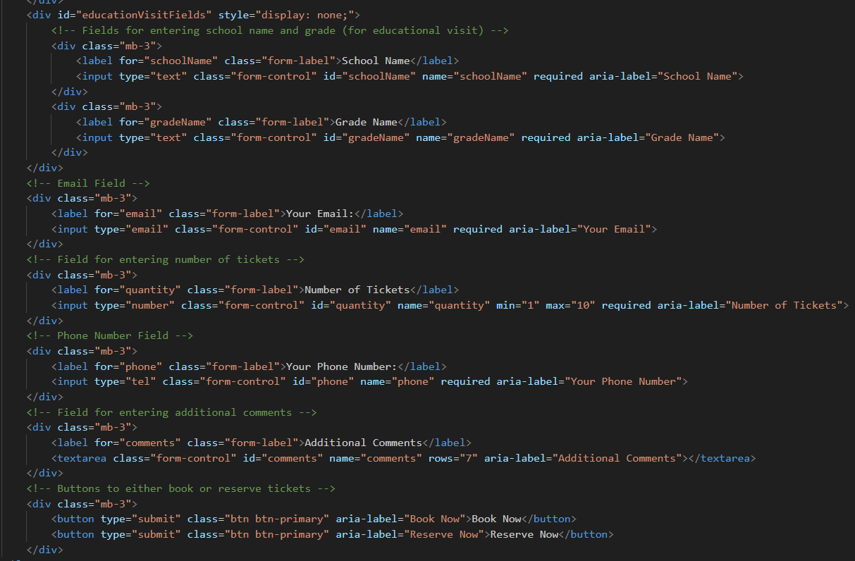

I have added aria-labelledby attribute to the form to reference a label for the form and aria-label attributes to form elements for accessibility, providing alternative labels where necessary. I have used label elements to associate form fields with their labels, improving accessibility and usability. I ensured that buttons have descriptive labels using aria-label which improves accessibility for users of assistive technologies.

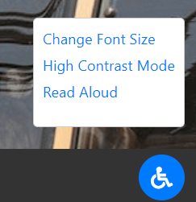

24/04/2024

**Accessibility button**

I have implemented accessibility button in my final prototype. I placed this button at the bottom right corner of webpage. It represented by an icon (wheelchair). I have chosen blue colour foe this button which will make this button more visible and accessible for all the users. I also added implemented an accessibility menu. When user clicked, it toggles the visibility of the accessibility menu. The accessibility menu is a dropdown menu. It contains links to various accessibility features or options that users can activate or adjust to enhance their browsing experience which I will develop in my final solution. In my final solution I will expand the accessibility menu to include more options based on user feedback and accessibility guidelines

These features aim to make my website more inclusive and user friendly for individuals with disabilities, ensuring that they can navigate, interact with and understand my content effectively and can meet the W3C guidelines.

I still have to fix my cookie banner as there is a problem that whenever user visit the home page the cookie banner appears and when they go to other pages it disappear, So in final solution I will make sure once the cookies has accepted or rejected the cookies the banner will not appear again if they visit the home page and also they wont be able to visit any other page if they have not accepted or rejected the cookie consent banner.

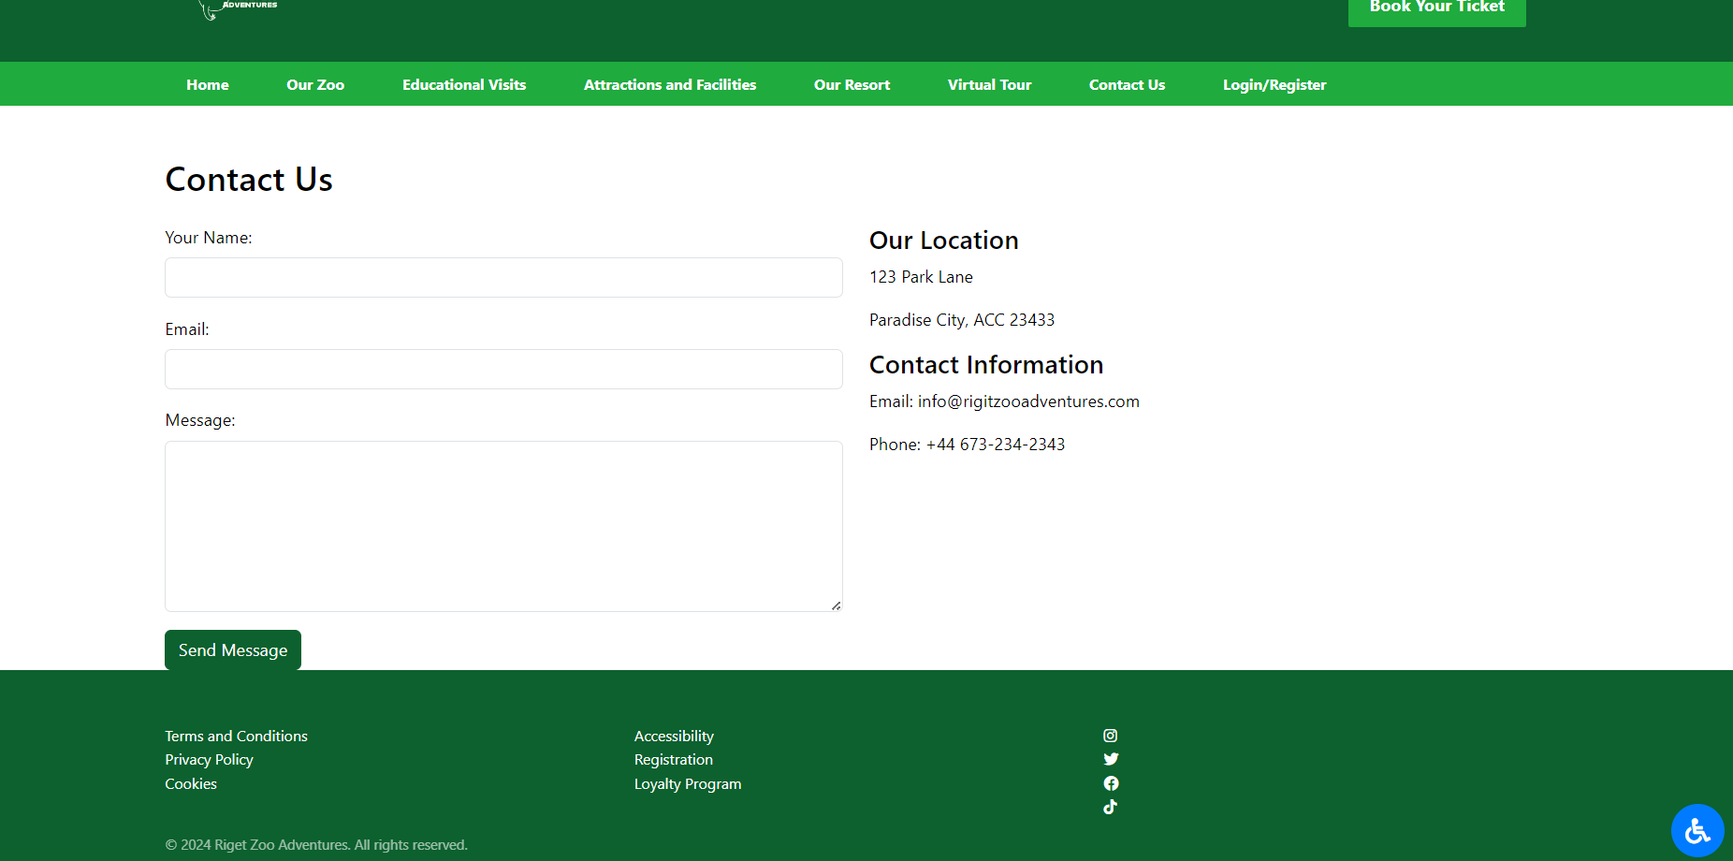**Contact Us Page**

Today is my last day of creating this prototype, So I have created a contact us page which is very simple and easy to use I also added some validation. If users have any queries, they can send message using this webpage.

Overall, I have tried to cover all the important aspects that my client Riget Zoo Adventures have asked me to develop that they offers to their customers. Firstly, they offers a safari style wildlife zoo for this I have created a our zoo page which have the highlights of the animals they offer I haven’t added most of the animals as I don’t have much time but I tried to add some of the animal pictures and their fun facts, I also added the pictures of zoo map just for the prototype however in my final solution I will add the real zoo image and zoom in and zoom out options so uses can easily find out what Rigit Zoo offers and also a option to download that map so when they visit they will be able to find the places they wish to visit.

I also have an on-site hotel page, educational visit page which also covers the support educational materials, zoo and resort booking pages which allow user to reserve and book a ticket of the zoo however I haven’t connected that page with database which I will do in my final solution. Moreover, I have connected room booking page with database but in my final solution I will add a function that will provide users a real time information about the availability of the rooms.

I have created a login and registration page and also connected it with database. I have used all the validations to make sure both forms are user friendly and give users clear error messages. I also added a validation to hash user passwords to keep their data save.

I have tried to add wide range of accessibility features, but I still have some to implement which I will do in my final solution.

I have created a loyalty reward scheme and displayed all the benefits users can get if they sign up for this scheme.

I also created a dashboard page for when user log in to their account that page will redirect them to dashboard where they can manage bookings but that page is still under construction.